

**Individual Assignment**

**TECHNOLOGY PARK MALAYSIA**

**CT051-3-M-DM**

**Data Management**

**Assignment Part-2**

**APUMF2204DSBA(DE)(PR)**

**Student’s TP: TP067696**

**Student’s Name: Mr. Muhammad Arif Bin Jamaluddin**

**Lecturer’s Name: Dr. MURUGANANTHAN VELAYUTHAM**

# **Abstract**

The topic of this assignment is mass shooting in USA where gun violence datasets from 2013-2018 is used to study about data management. This assignment required to prepared and explored the datasets selected which in these cases is gun violence whereby several justifications of pre-processing, transformation and feature engineering method is implemented using SAS studio. The main contents of this assignment part 2 is method section where it consists of initial data exploration, data pre-processing, exploratory data analysis (EDA) and hypothesis. Next is followed up by discussion where it summarizes the finding of all the method parts. Introduction and related work briefly explain on the background information about gun violence in United States whereby it explained the reason why mass shooting happens and statistics of mass shooting recorded in the past in United States. The purpose of this data analysis is to study the topic by doing statistical approach on the datasets to find the relationship and correlation between the variables.

Keyword; Gun violence, SAS studio, mass shooting, USA, data management

**Table of Contents**

**Abstract** 2

**Introduction** 4

**Related work** 5

**Method** 7

**Discussion** 35

**Conclusion** 37

**References** 37

# **Introduction**

Mass shooting has been a recent phenomenon in the United States of America where it happens very frequently especially in school, public areas or where there is a mass gathering of people.

Before going into further explanation on the statistics, what is the definition of mass shootings? Mass shootings can be defined as when a mass murderer that kills more than four people in an event excluding himself, usually in a single location or a place by Federal Bureau of Investigation (FBI) in the 1980s (Krouse and Richardson, 2015). These mass public shootings are rare events—they constitute less than 15 percent of all mass killings in the United States and are responsible for less than 0.5 percent of all homicides (Duwe, 2020). Although this statistic shows that the number is insignificant but it still poses threat to the American society.

There are a lot of statistics and research papers recorded by the US government where for example in 24 May 2022 where recently happen this year, an 18-year-old male teenager shoot and killed 21 people at Robb Elementary school in Uvalde, Texas. The statistics shows that in 2022, there is already 200 mass shootings incidents happen in USA where 27 of it comes from mass shooting incidents happen in school.

The trend of mass shootings is increasing in USA from 149 mass shootings and 27 deaths per day in 1999 to 248 mass shootings and 51 deaths per day in 2021 (Federico G de Cosío, 2022). The negative impacts of mass shootings can be seen on the economic cost for all type of gun violence where each year the US government spend $12.7 billion USD or the local government of each states spend roughly $34.8 million USD to deal with aftermath of gun violence (Everytown. The Economic Cost of Gun Violence, 2021). Staggering amount of $280 billion USD is the annual expenditure for taxpayers, survivors, families, employers, and communities to deal with the impact of gun violence or mass shootings.

There are different methods to defined mass shooting where the findings can be summarized by the traits of the mass shootings for example offender behaviors, types of firearms used and community level shootings.

It can be proved that by using data science and analytical tools such as statistics, gun shooting related fatality can be backed up using data science evidence to regulate gun ownership in United States of America to prevent more from this incident to happen. The flow of this papers starts with related work where it discussed about the research papers discussing the datasets about mass shooting incidents in United States of America. Then, method section contained detail exploration of the dataset, pre-processing, feature engineering, EDA and hypothesis about the mass shooting in United States of America where SAS codes are implemented to study about this topic especially on exploring the data and evaluates it.

In the domain of data science most data are unstructured where it is incomplete such as missing values and outliers where several methods can be applied to deals with this noisy data. Then discussion part where the summary of findings can be discussed about the methodology part and eventually discussion to concluded everything for this assignment paper.

# **Related work**

In this section discussed about research papers regarding mass shootings incidents in USA based on the data collected by the USA government (statistics and reports). Mass shootings definition according to Federal Bureau Investigation (FBI) is usually with the purpose to address criminal profiling procedures (Ressler, Burgess, and Douglas, 1988). There are diverse definitions of mass shootings from the news or media outlets that reports on these mass shootings incidents where it can confuse the public on the relationship between gun law and mass shootings trends (Elsass, H. Jaymi, Jaclyn Schildkraut, Mark C. Staffor, 2016).

In USA, the homicide rate caused by gun violence is 26 times higher compare to developed countries (GunPolicy.org,2022) and it shows that in several states in USA with fragile and loose gun law restrictions and highest gun ownership per person shows greater rates of mass shootings incidents (Paul M. Reeping et al,2019). Because of this event, this sparks debate among the general public to have a better and much more strict gun control legislation to prevent same tragedies from happening again. Thus, perhaps with tighter gun control the probability of mass shootings will likely less to happen.

The victims of these mass shootings can be statistically analyzed based on the death age by groups, ethnicity, and the demographic or the regions in the USA where the shootings take places. It shows that 64% of all death rates is people from age range between 15-24 and 25-34 and also most of deaths are among males. The cumulative death by ethnic group shows that the highest is black/African American, followed by white, Hispanic, Asian/pacific islander and American Indian/ Alaskan native. The trend can be seen for cumulative deaths by month where January and July are the peaks month correlated with mass shootings and after that it starts to decline from august to December.

Mass shootings patterns or behavior can be identified by this characteristic such as it was executed by people who carry firearms or gun illegally, that person shows some sign of not normal behaviors such as mental illness and had history of domestic violence at home. There are several definitions what constitute mass shootings for example the casualty threshold (deaths or injuries caused by the firearms), location of the mass shootings takes place for example school, workplace, residential area, malls and motivation of the shooters. For example, there are several threshold definitions on mass shooting such as two or more injured victims is considered threshold by (Lott and Landes,2000). Whereas other definition used 6 victim casualty thresholds by (Kleck, 2016).

There are differences between mass shootings that involves domestic and gang violence than indiscriminate killings in public events such school shootings where several researchers and analysts state that it should categorized separately. Definitions proposed by (Duwe, Kovandzic, and Moody,2002) states that mass communal shootings exclude that both the sufferer and convicts were participating in illegal activities for example crime, gang members and drug dealings.

Furthermore, mass shootings events happen in public area where the offender choose the victims randomly proposed by (Gius,2015) (Luca, Malhotra, and Poliquin, 2020). But then again, this approach currently has flaw such as its overlooking significant percentage of gun violence that comes from family or assault linked murder (Fox and Levin, 2015). It is a very subjective in a way that how the offender choosing the victims indiscriminately or the incidents is related to crime or gang activities. Thus, accurate information from most of the police reports or news about this mass shootings events or not included whether what is the shooter’s main motivation or is there any correlation with gangs’ members.

From 2009 until 2020, there were 1363 casualties of mass shooting where 947 people were killed and 240 were injured. Based on this numbers at least the number of children and teens death are 362 and 21 law enforcements are killed and the rest 35 are wounded. There is interesting pattern noticed where most of shooters acted alone and overall 32% percent of the mass shooters which roughly at 92 people eventually end up killing themselves by suicide. The rest of the perpetrator end up killed by the police which are around 24 and the remaining 145 were arrested into custody by the police.

Although it is known that mass shootings that occurs in public especially school gathers more attention media, but most of it happens at home around 61% and the rest happen at public places such as school, bars, restaurants and malls. Unfortunately, there is a lack of research regarding gun violence in USA and also the government does not provide sufficient funding and thus this leads to donations and private funding to conduct research on understanding more the cause of mass shooting in USA.

Thus, the objectives of this assignment are to explore mass shootings/ gun violence datasets using SAS codes to understand the correlation between dependent and independent variables in the datasets obtained.

# **Method**

The datasets used for this assignment obtained from Kaggle where the title is obtained from Gun Violence Data where it shows all the statistics and record of 260k gun violence accidents in USA from 2013-2018. The aim of this datasets is to make learned predictions about upcoming trends regarding the gun violence using statistical method. The detail exploration and explanation are conducted using SAS code.

**Initial Data Exploration**

The first step is using visual exploration to understand what is in a dataset and the characteristics of the data. Thus, using SAS software the codes below is generated by importing excel into SAS Studio under WORK.IMPORT1 function and the code is executed to obtain information as shown in figure 1 and 2. In this assignment the imported data obtained originally contained huge amount of observations data about mass shooting from 2013 until 2018.

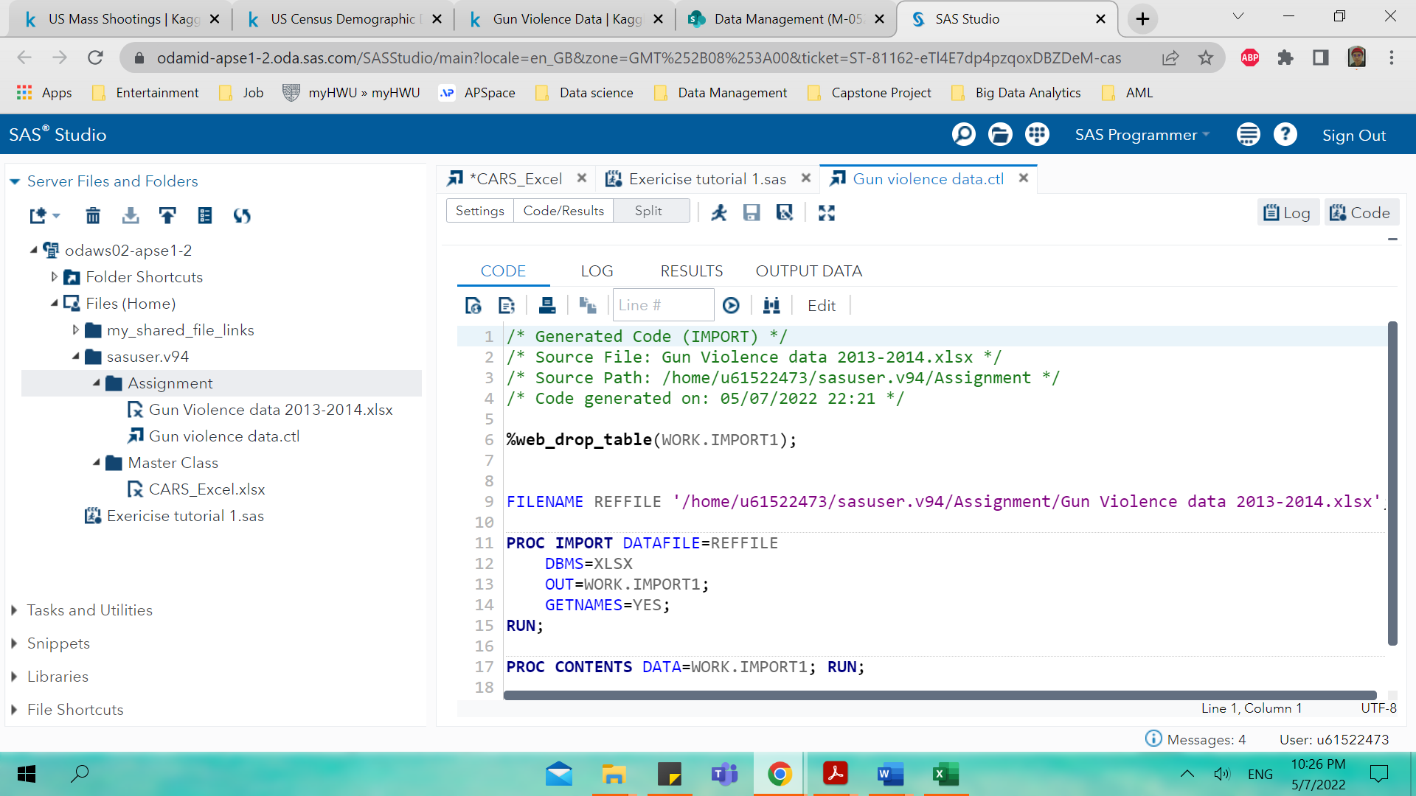

Figure

Based on figure 2 it shows that the data has 52133 observations 29 variables/attributes.

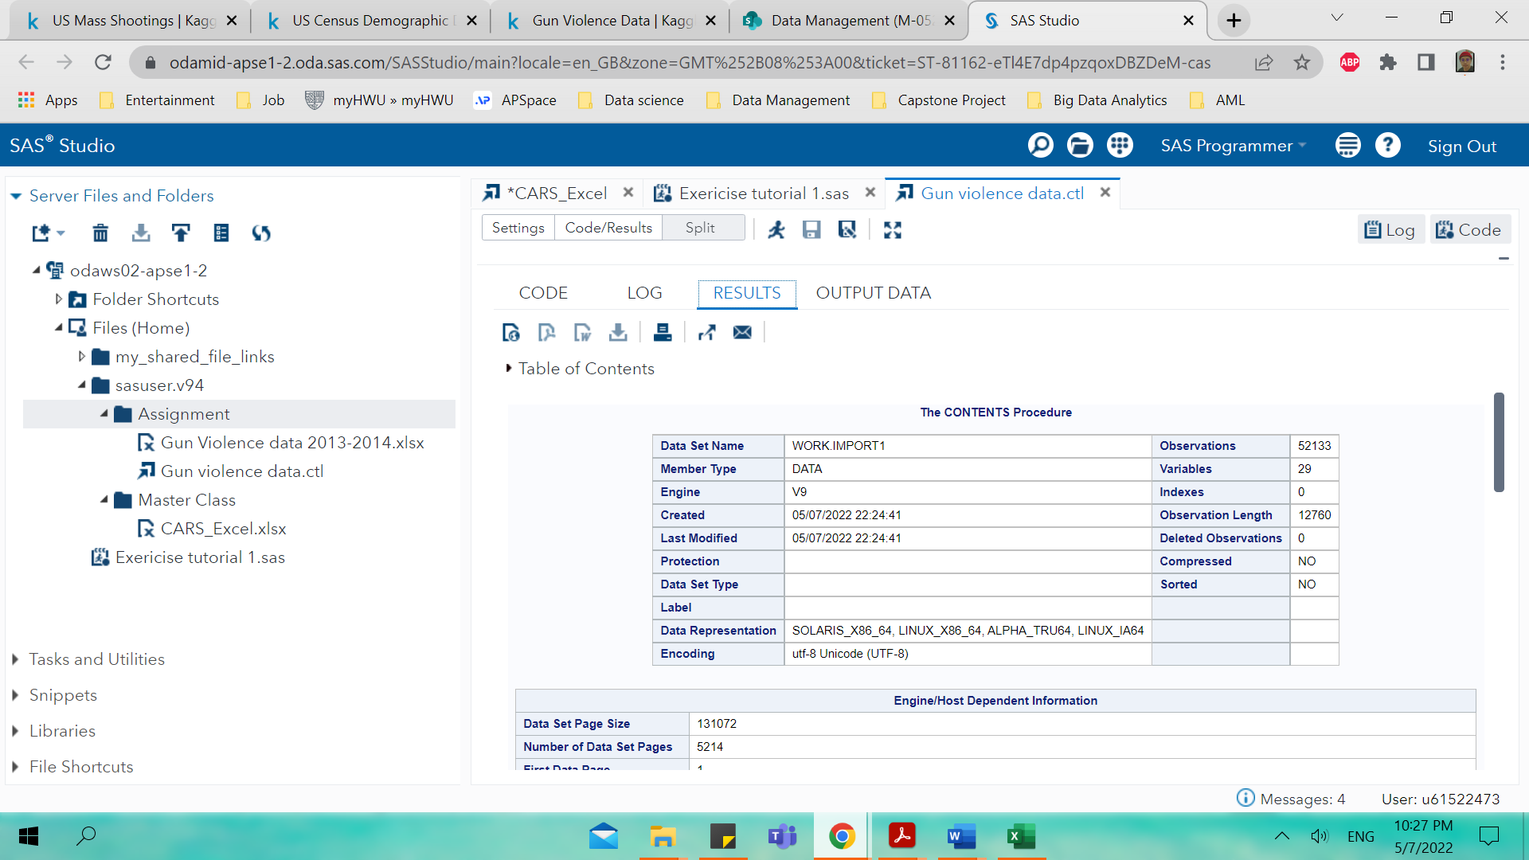

Figure

Categorize the data into categorical and continuous. Table 1 shows the categorical and continuous data type for this dataset where it’s divided into categorical and continuous variables.

Table

|  |  |
| --- | --- |
| **Categorical** | **Continuous** |
| 1. State 2. City_or_country 3. Address 4. Incident_url 5. Source_url 6. Gun_type 7. incident_characteritics 8. location_description 9. notes 10. participant_gender 11. participant_name 12. participant_relationship 13. participant_status 14. participant_type 15. sources 16. participant_age_group 17. participant_age 18. gun_stolen | 1. incident_id 2. date 3. n_killed 4. n_injured 5. incident_url_fields_missing 6. congressional_district 7. latitude 8. longitude 9. n_guns_involved 10. state_house_district 11. state_senate_district |

Table 2 below shows the data description of the variables from the gun violence datasets obtained from Kaggle from 2013 and 2014 and the data contained 29 attributes.

Table

|  |  |
| --- | --- |
| Variables/attributes | Descriptions |
| incident_id | Incident identification number |
| date | Date of the shooting took place |
| state | The state where the shooting took place |
| city_or_county | The city where the shooting took place |
| address | The address of the event |
| n_killed | The number of victims killed |
| n_injured | The number of victims injured |
| incident_url | Incident sources url |
| source_url | Sources of the website link about the detailed event |
| incident_url_fields_missing | The incident url fields missing |
| congressional_district | Legislative districts |
| gun_stolen | Gun stolen |
| gun_type | Type of gun used |
| incident_characteristics | The severity of the casualties |
| latitude | Latitude value of the event |
| location_description | The description of the event location |
| longitude | Longitude value of the event |
| n_guns_involved | The number of guns involved |
| notes | Detail description of the event |
| participant_age | The age of the participant |
| participant_age_group | The age of the participant in group manner |
| participant_gender | The participant gender |
| participant_name | The participant’s name |
| participant_relationship | Relationship between offender and victim |
| participant_status | The offender status after the event |
| participant_type | The participant type |
| sources | The sources of the news |
| state_house_district | State house district codes |
| state_senate_district | State senate district codes |

The next part is to identify the data into characters or numerical type as shown in table 3 below. Based on table 3 it shows that there are 18 Char type data and 11 Num type data and figure 3 is used to execute the SAS code to get the output in table 3.

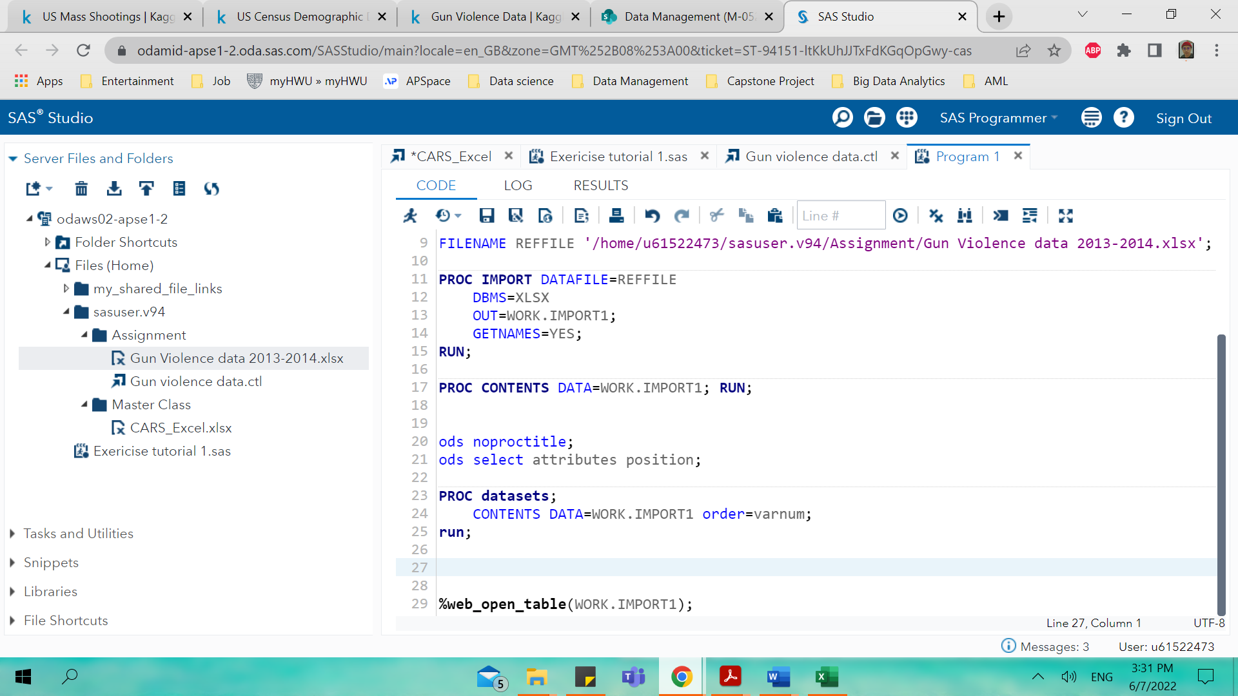

Figure

Table

| **Variables in Creation Order** | | | | | | |
| --- | --- | --- | --- | --- | --- | --- |
| **#** | **Variable** | **Type** | **Len** | **Format** | **Informat** | **Label** |
| **1** | incident_id | Num | 8 | BEST. |  | incident_id |
| **2** | date | Num | 8 | MMDDYY10. |  | date |
| **3** | state | Char | 20 | $20. | $20. | state |
| **4** | city_or_county | Char | 42 | $42. | $42. | city_or_county |
| **5** | address | Char | 97 | $97. | $97. | address |
| **6** | n_killed | Num | 8 | BEST. |  | n_killed |
| **7** | n_injured | Num | 8 | BEST. |  | n_injured |
| **8** | incident_url | Char | 50 | $50. | $50. | incident_url |
| **9** | source_url | Char | 255 | $255. | $255. | source_url |
| **10** | incident_url_fields_missing | Num | 8 | BEST. |  | incident_url_fields_missing |
| **11** | congressional_district | Num | 8 | BEST. |  | congressional_district |
| **12** | gun_stolen | Char | 3808 | $3808. | $3808. | gun_stolen |
| **13** | gun_type | Char | 3808 | $3808. | $3808. | gun_type |
| **14** | incident_characteristics | Char | 618 | $618. | $618. | incident_characteristics |
| **15** | latitude | Num | 8 | BEST. |  | latitude |
| **16** | location_description | Char | 56 | $56. | $56. | location_description |
| **17** | longitude | Num | 8 | BEST. |  | longitude |
| **18** | n_guns_involved | Num | 8 | BEST. |  | n_guns_involved |
| **19** | notes | Char | 273 | $273. | $273. | notes |
| **20** | participant_age | Char | 148 | $148. | $148. | participant_age |
| **21** | participant_age_group | Char | 318 | $318. | $318. | participant_age_group |
| **22** | participant_gender | Char | 224 | $224. | $224. | participant_gender |
| **23** | participant_name | Char | 401 | $401. | $401. | participant_name |
| **24** | participant_relationship | Char | 182 | $182. | $182. | participant_relationship |
| **25** | participant_status | Char | 328 | $328. | $328. | participant_status |
| **26** | participant_type | Char | 408 | $408. | $408. | participant_type |
| **27** | sources | Char | 1631 | $1631. | $1631. | sources |
| **28** | state_house_district | Num | 8 | BEST. |  | state_house_district |
| **29** | state_senate_district | Num | 8 | BEST. |  | state_senate_district |

The next part is the discussion of descriptive statistics where it consisted of summary statistics, univariate and bivariate analysis, missing values and outlier treatment for the missing values data. In this section it contained the identification values of the summarising properties for each attribute including frequency and spread e.g., value ranges of the attributes, frequency of values, distributions, medians, means, variances, and percentiles.

For example, to display mean, standard deviation, minimum and maximum value for the variables of n_killed and n_injured the code in SAS is used as below,

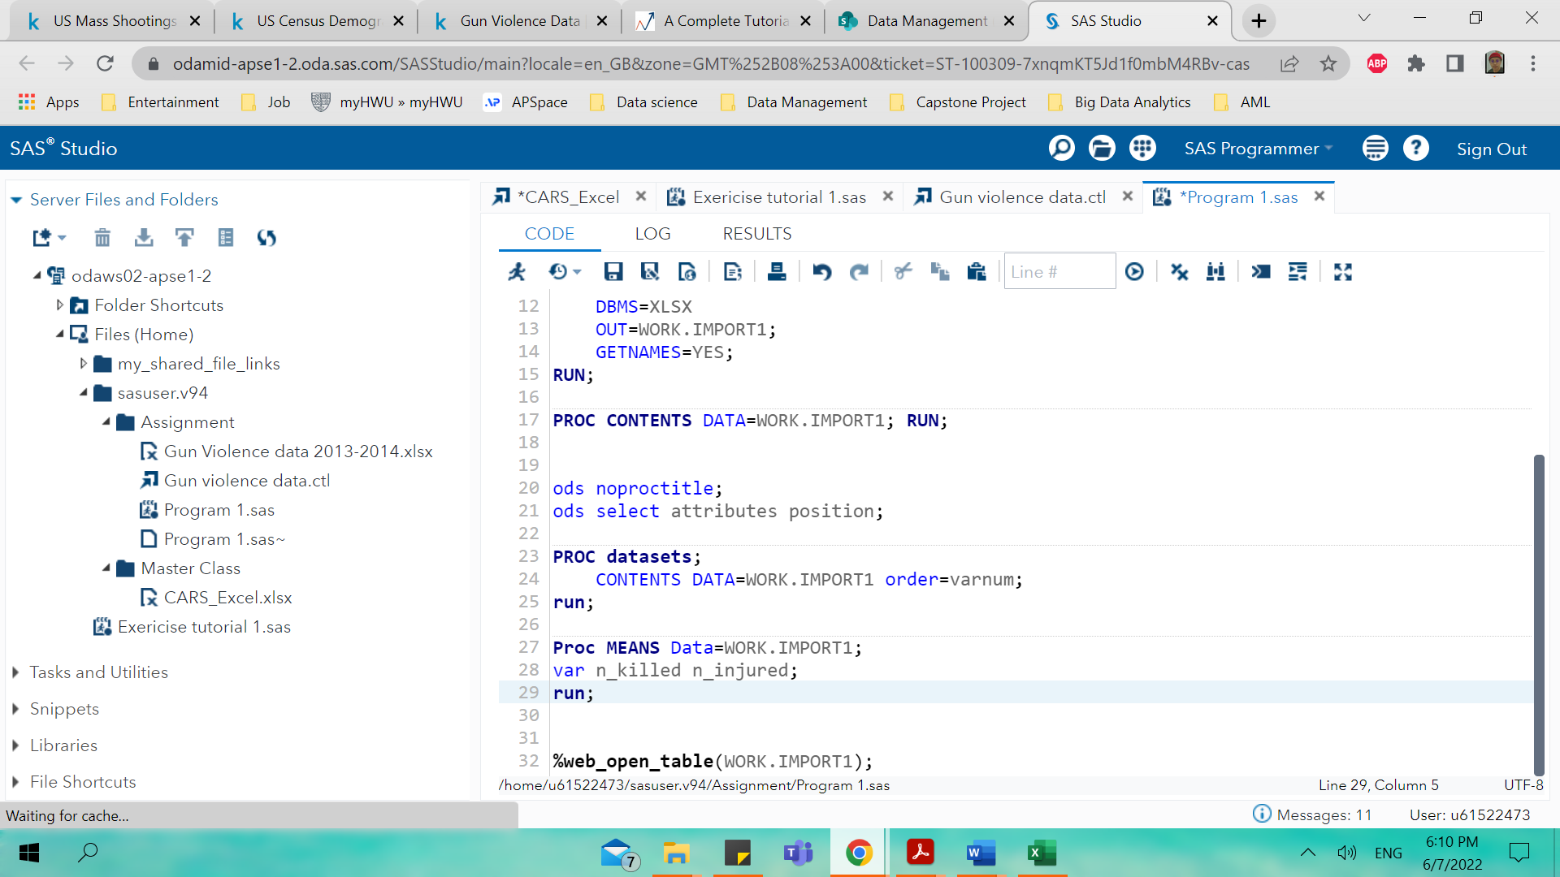

Figure

**The MEANS Procedure**

Table 4

| **Variable** | **Label** | **N** | **Mean** | **Std Dev** | **Minimum** | **Maximum** |
| --- | --- | --- | --- | --- | --- | --- |
| n_killed  n_injured | n_killed  n_injured | 52132  52132 | 0.2469500  0.4600054 | 0.5141859  0.7535712 | 0  0 | 11.0000000  19.0000000 |

The values of mean, standard deviation, minimum and maximum for n_killed and n_injured are shown above in table 4. For example, to display the mean, standard deviation, minimum and maximum value for all numerical variables the SAS code is used as below at figure 5,

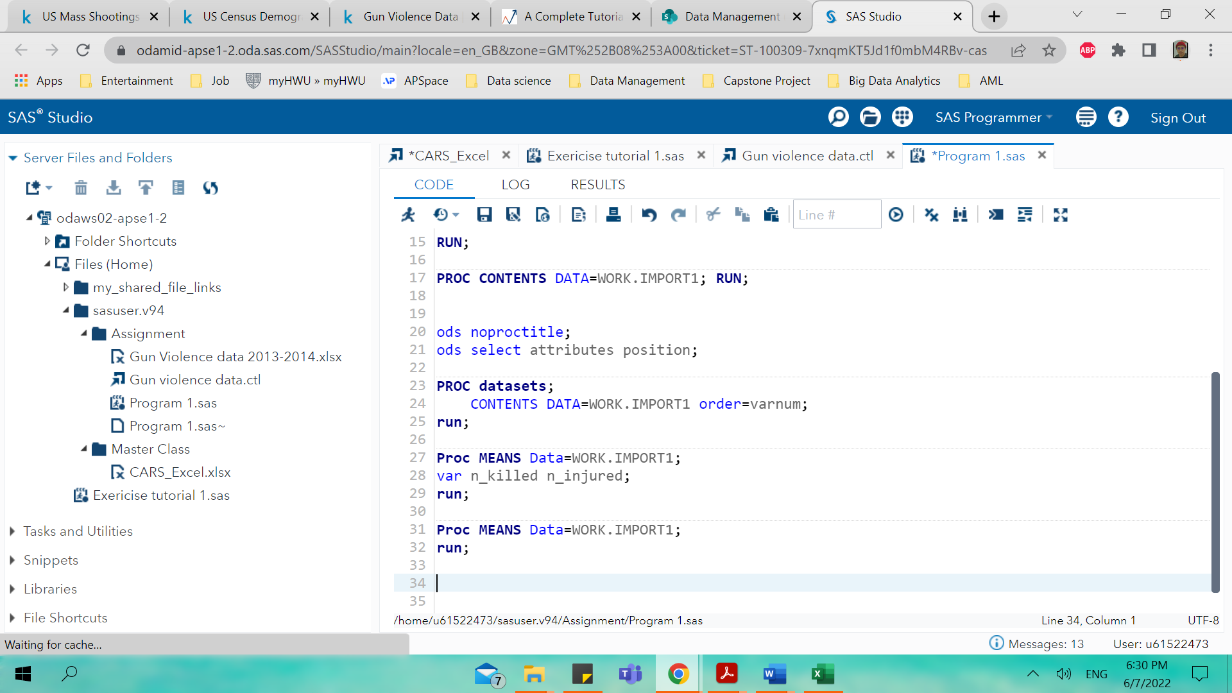

Figure

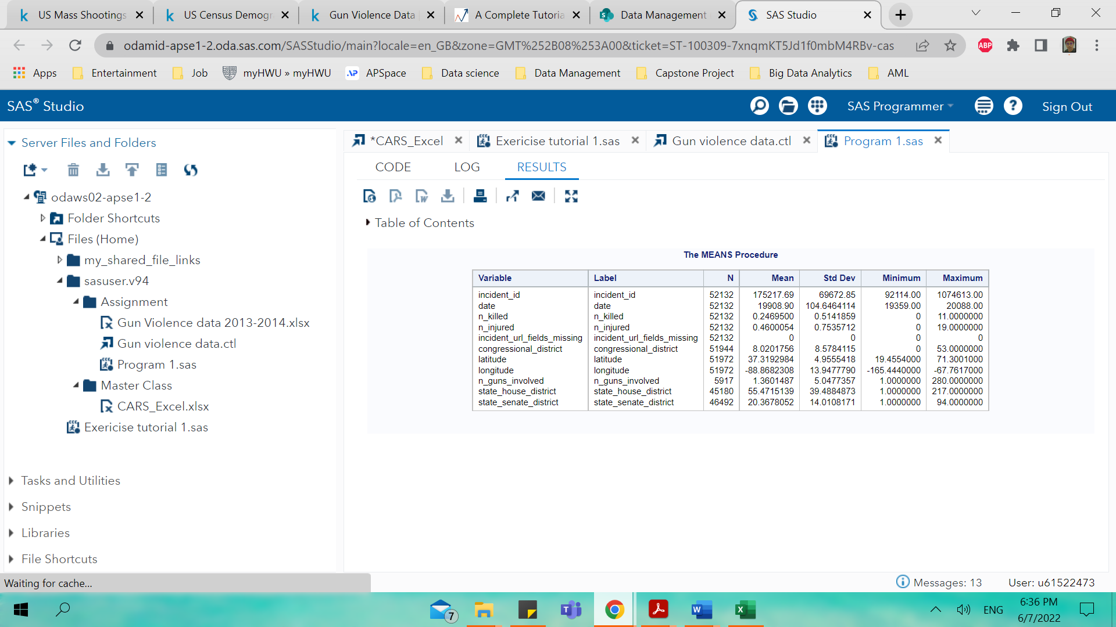

Figure

In Figure 6 above, all the mean, standard deviation, minimum and maximum value for all numerical variables is shown by the output. For example, to display MIN, MAX and SUM for the variable n_killed and n_injured is shown in SAS code below in figure 7.

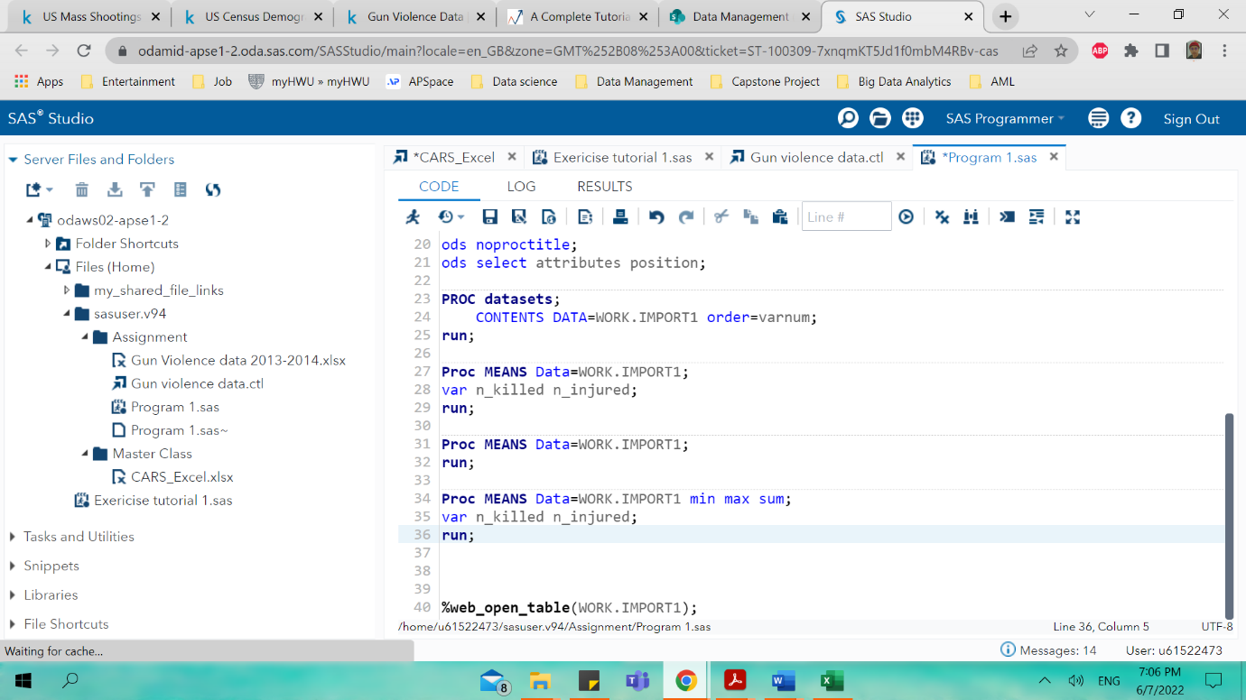

Figure

**The MEANS Procedure**

Table

| **Variable** | **Label** | **Minimum** | **Maximum** | **Sum** |
| --- | --- | --- | --- | --- |
| n_killed  n_injured | n_killed  n_injured | 0  0 | 11.0000000  19.0000000 | 12874.00  23981.00 |

For example, to display the number of missing values in all variables the SAS code is used shown below.

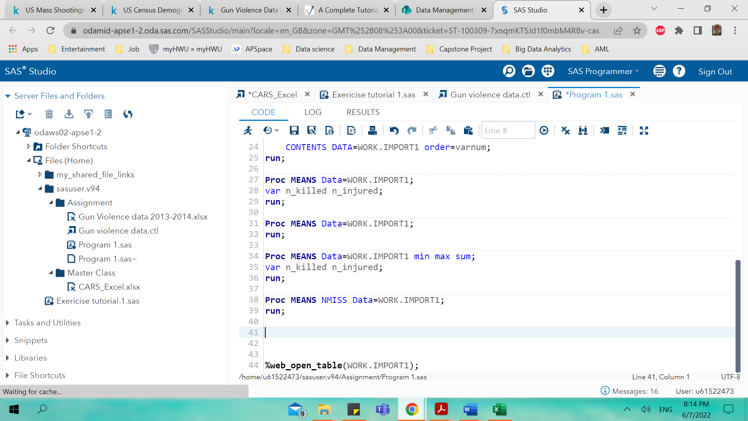

Figure

**The MEANS Procedure**

Table

| **Variable** | **Label** | **N Miss** |
| --- | --- | --- |
| incident_id  date  n_killed  n_injured  incident_url_fields_missing  congressional_district  latitude  longitude  n_guns_involved  state_house_district  state_senate_district | incident_id  date  n_killed  n_injured  incident_url_fields_missing  congressional_district  latitude  longitude  n_guns_involved  state_house_district  state_senate_district | 1  1  1  1  1  189  161  161  46216  6953  5641 |

It shows that variable of n_guns_involved shows the highest N Miss value at 46216 and all of the previous section discussed is data from 2013 and 2014. For this section comparison is made between data from 2014 and 2015 about the gun violence datasets and investigate the difference between different years and its relationship with the variables. The same SAS code is used and the output for 2014 and 2015 is shown below and figure 9 and 10 shows the results of the observations of both years.

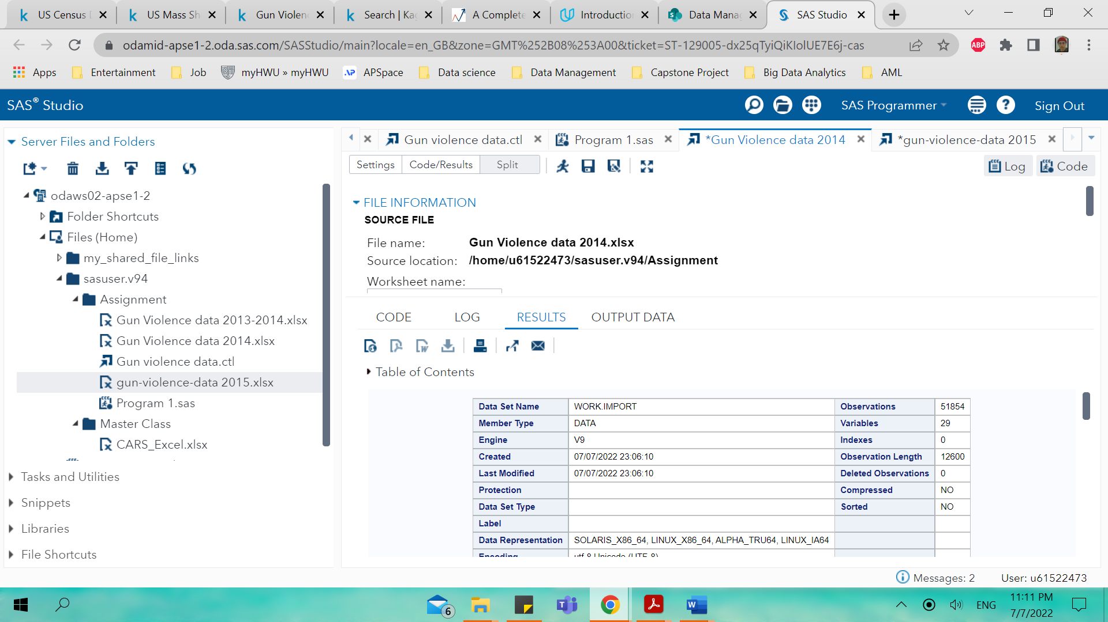

Figure

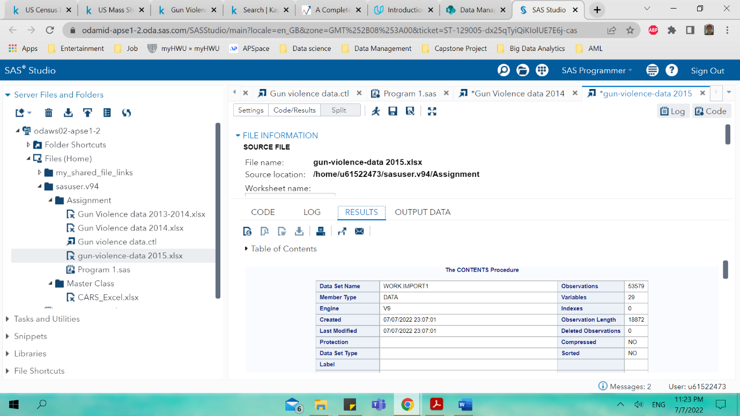

Figure

The number of observations in year 2014 of gun violence data is 51854 meanwhile for 2015 is 53579. Figure 11 shows the SAS code to get the output of the variables in figure 12 and 13.

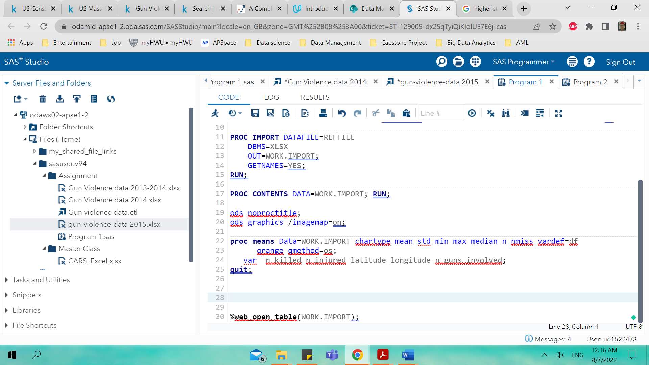

Figure

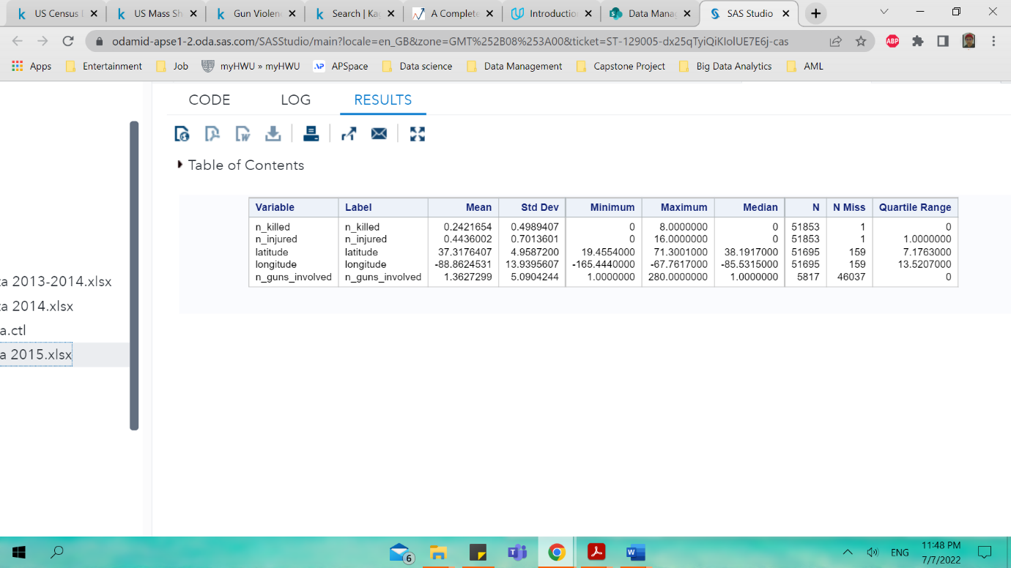

Figure of 2014 datasets of gun violence

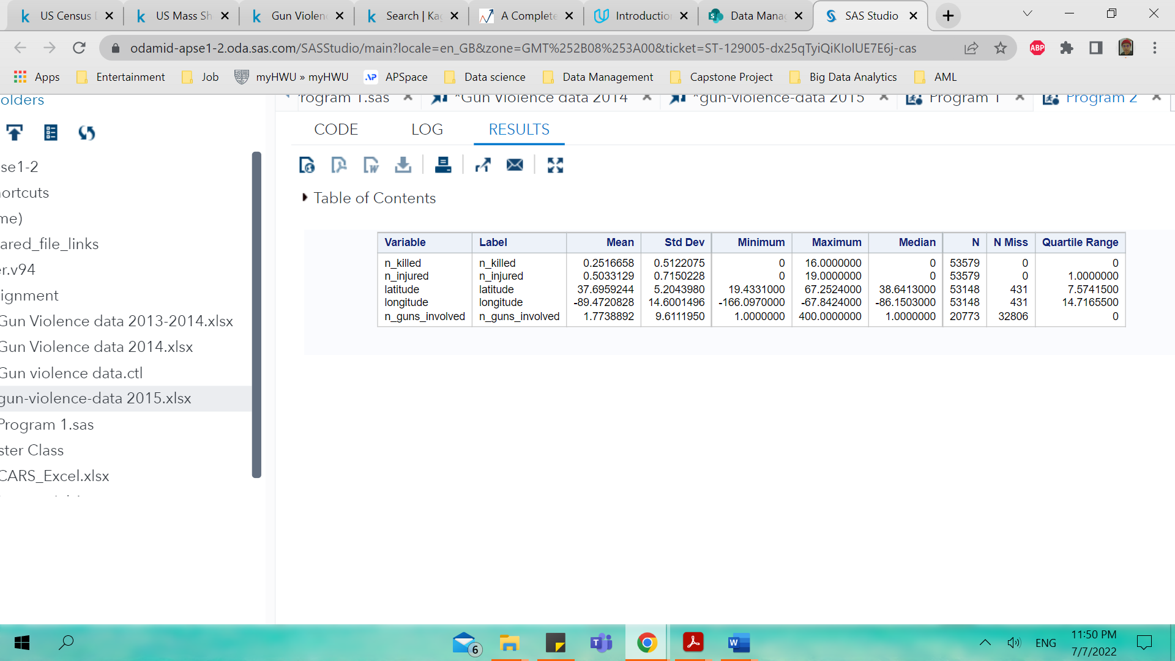

Figure of 2015 datasets of gun violence

It can be seen that n_killed, n_injured, latitude, longitude and n_guns_involved values in 2015 data shows much higher values of mean, standard deviation, minimum, maximum, median, N, N Miss and quartile range. The only similarities the values of n_killed, n_injured, n_guns_involved for both datasets are for minimum, median, and quartile range. The only odd data from between this two can be seen on n_guns_involved at median for 2014 datasets where it is lower than the one in 2015 which is 20773 and also the same for N Miss where in 2014 the value is 46037 which is much lower than 2015 at 32806. The next part is univariate analysis where analysis is done to know if the variable type is categorical or continuous. For continuous variable it is used to understand central tendency and the spread variable using data visualization tools to highlight the missing and outlier values. The first part is the explanation of the data visualization using boxplot and the latter part is histogram. The variables selected are n_killed, n_injured and n_guns_involved for the boxplot.

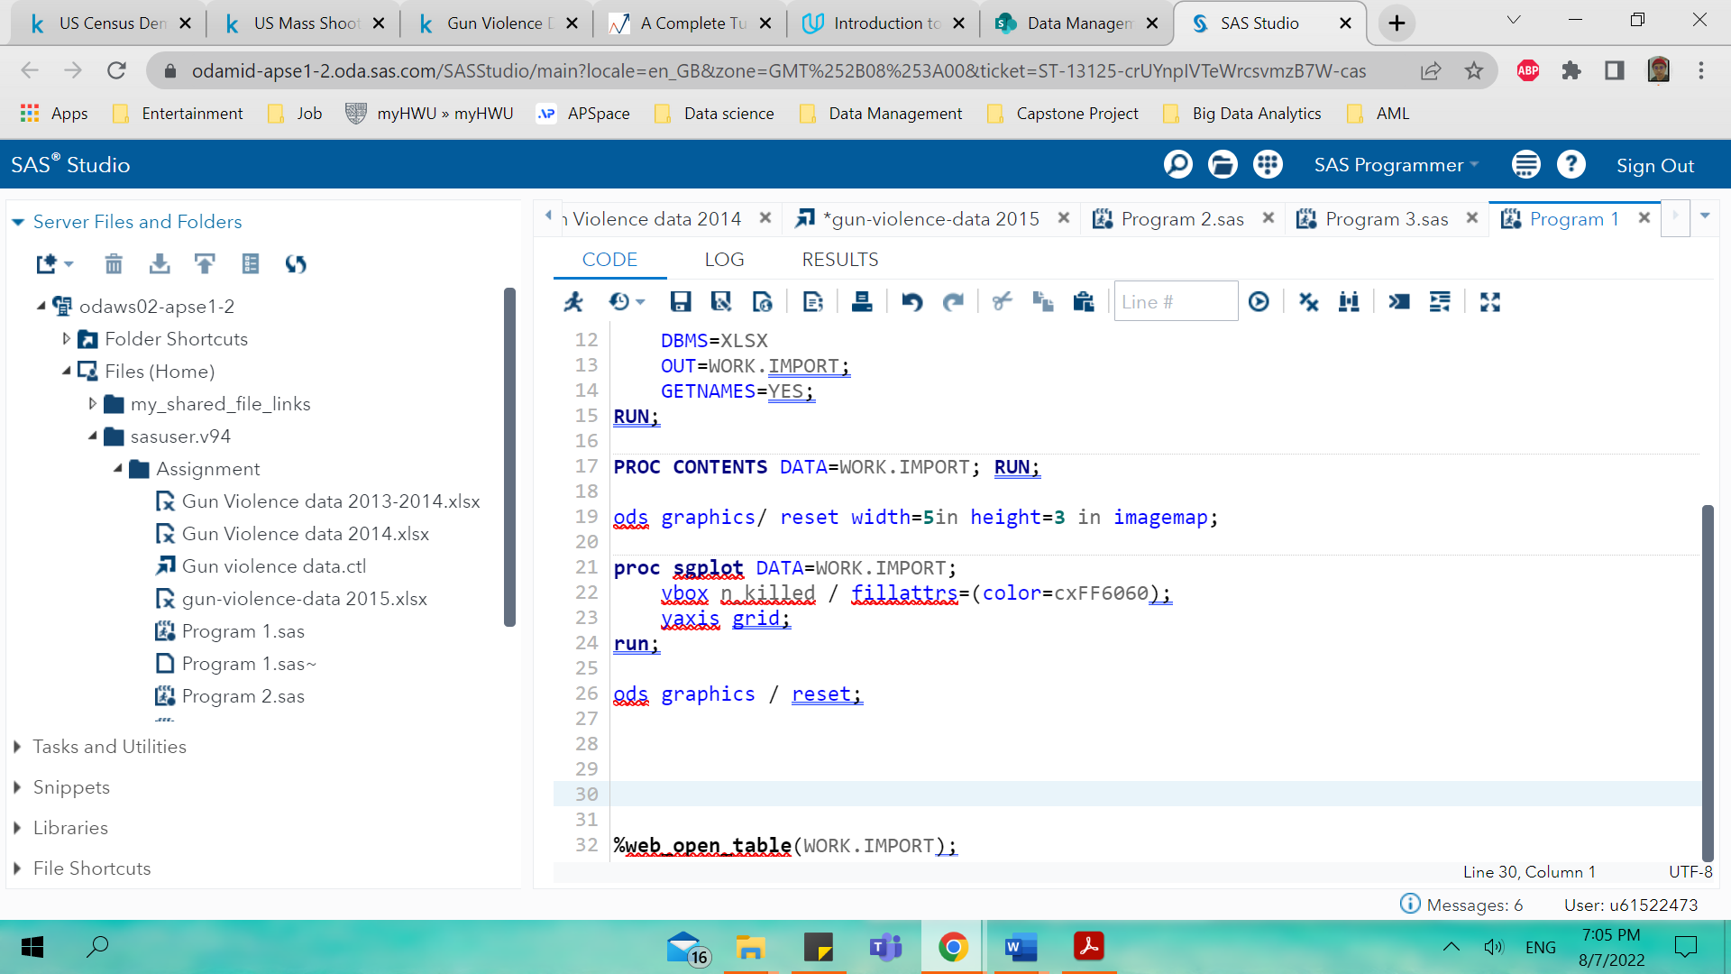

Figure

The SAS code in figure 14 is executed to get the boxplot as shown below.

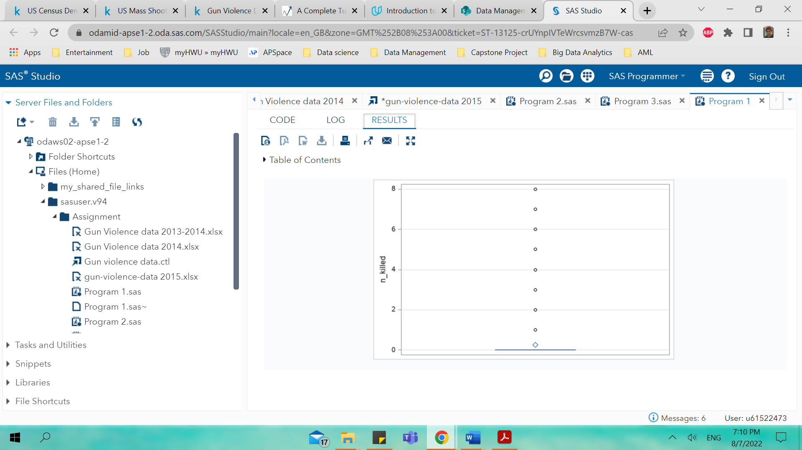

Figure

The figure below is SAS code for n_injured variables 2014 datasets

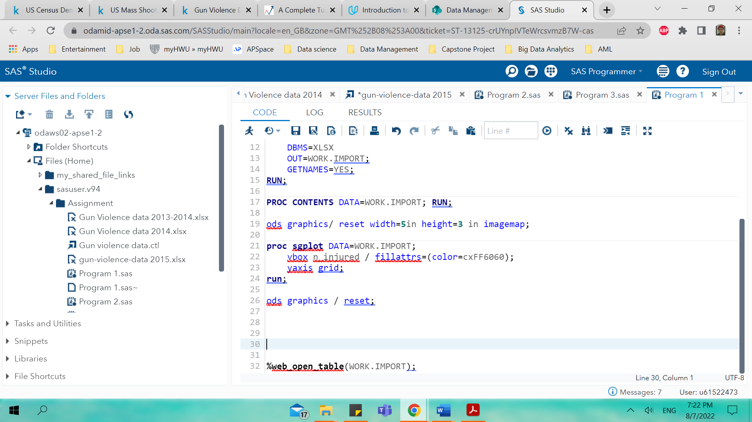

Figure

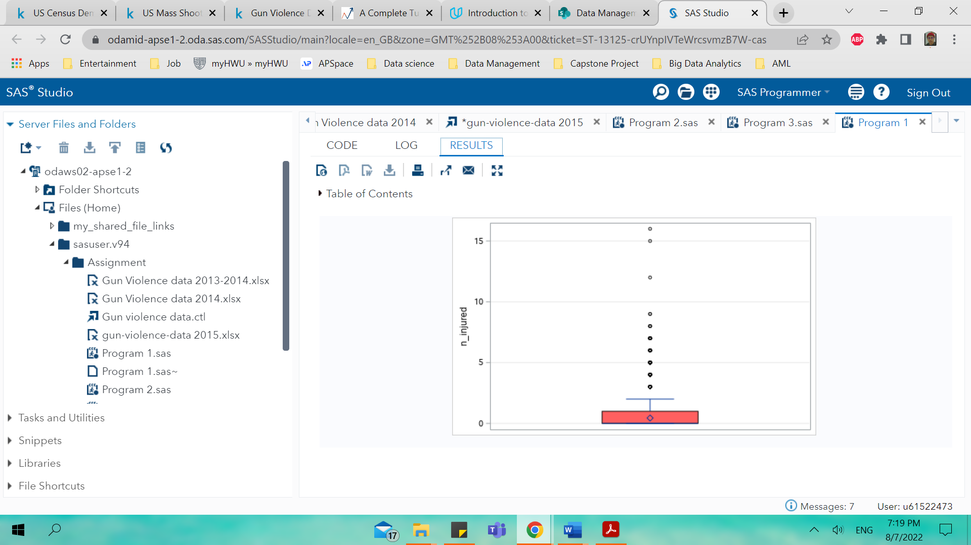

Figure

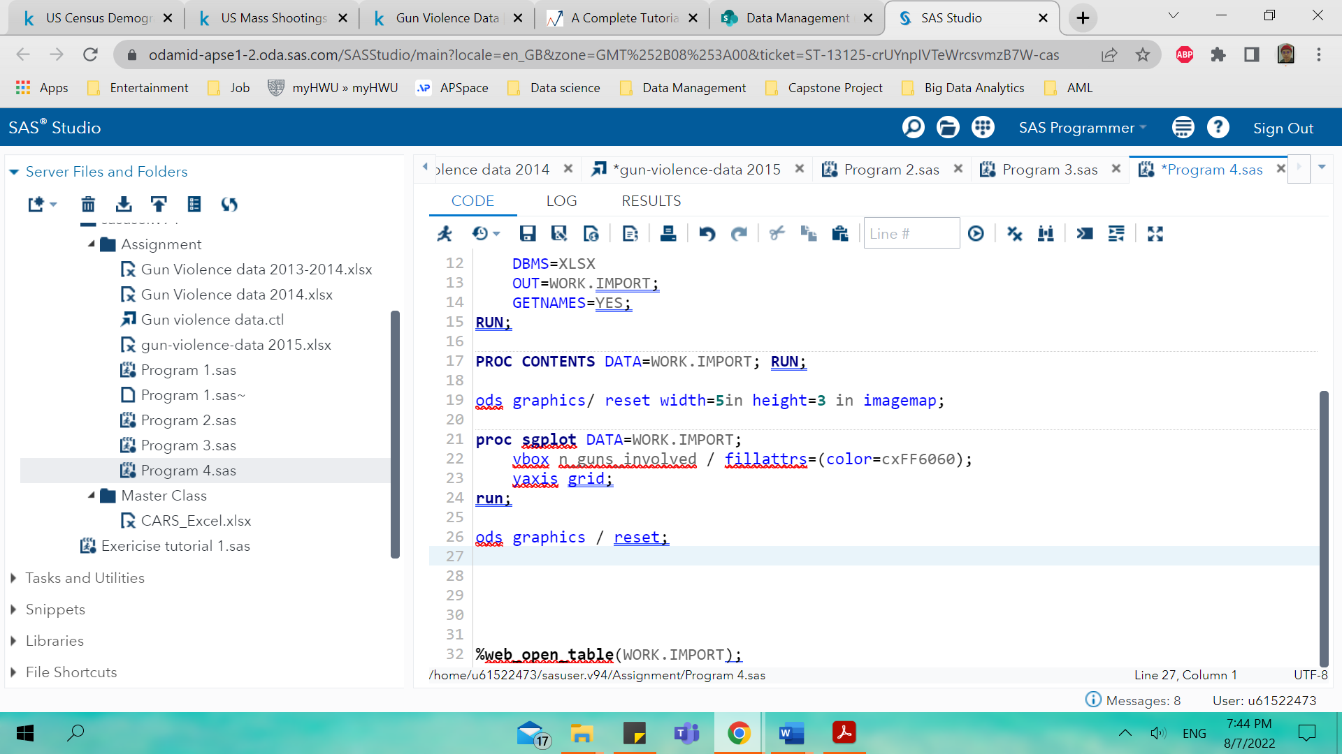

Figure

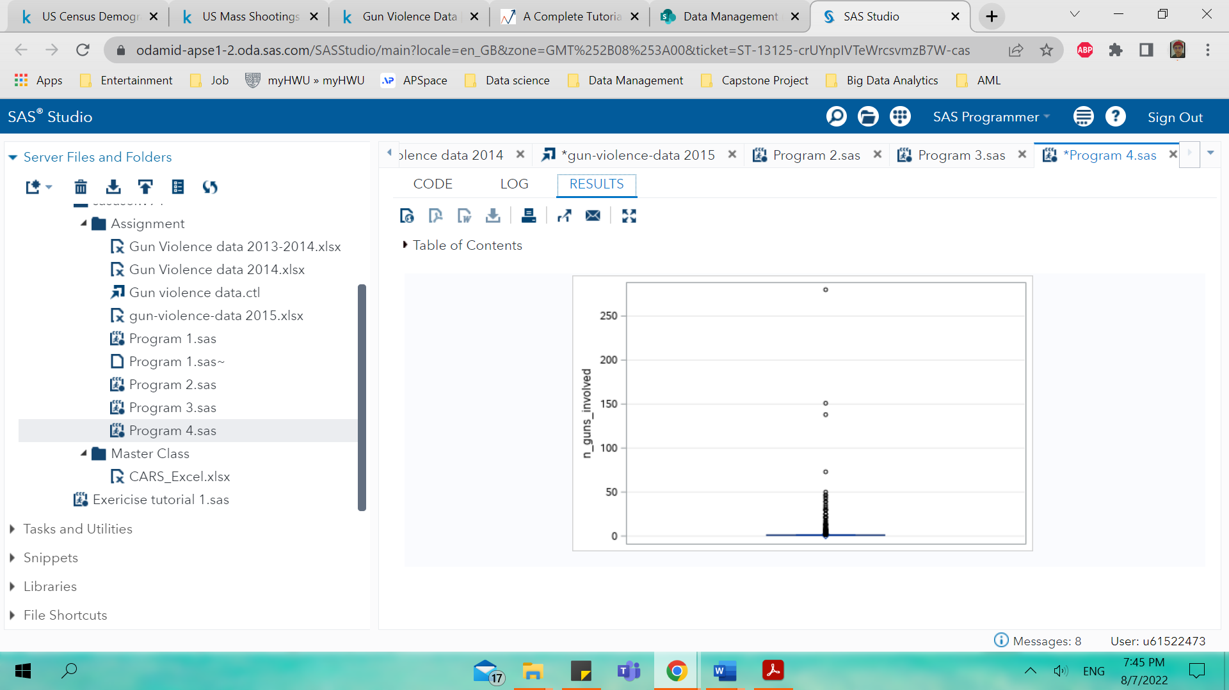

Figure

Figure 14-19 shows the SAS code and the boxplot of 2014 datasets of gun violence data. The next part is the SAS code and boxplot for 2015 datasets and comparison is done if there are any differences on the shape of boxplot. Figure 20 until 22 shows the boxplot of 2015 gun violence datasets.

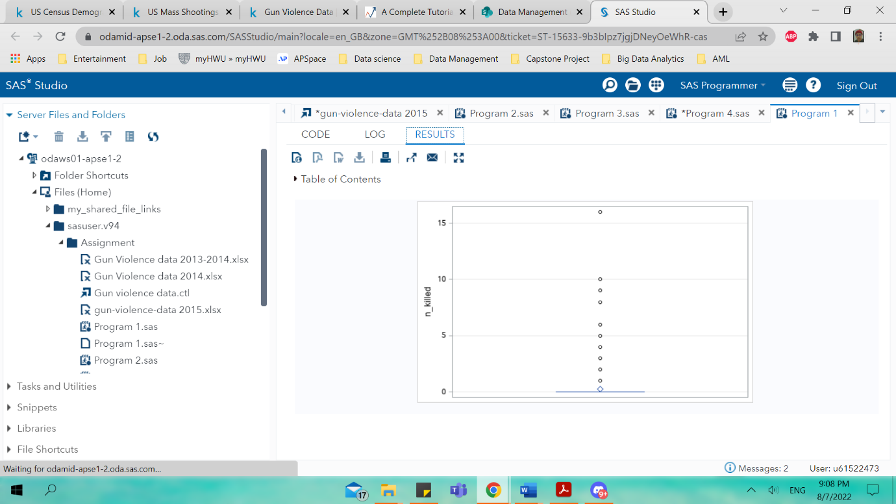

Figure

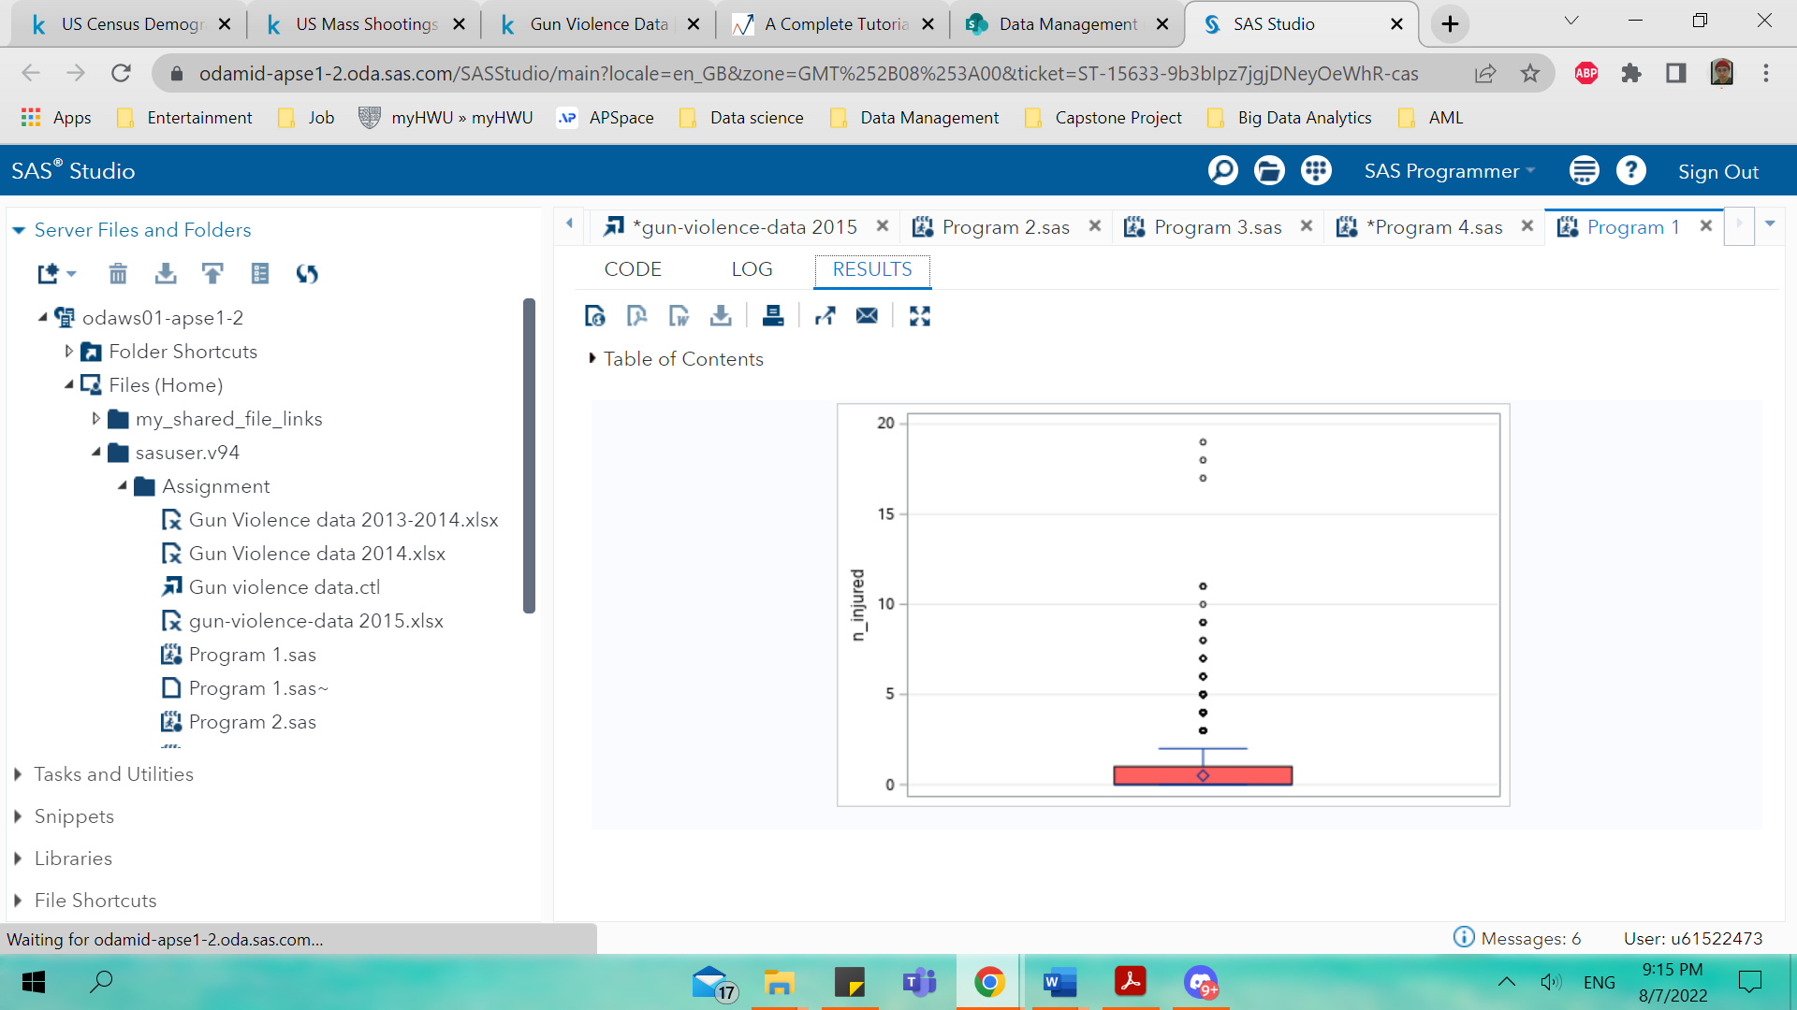

Figure

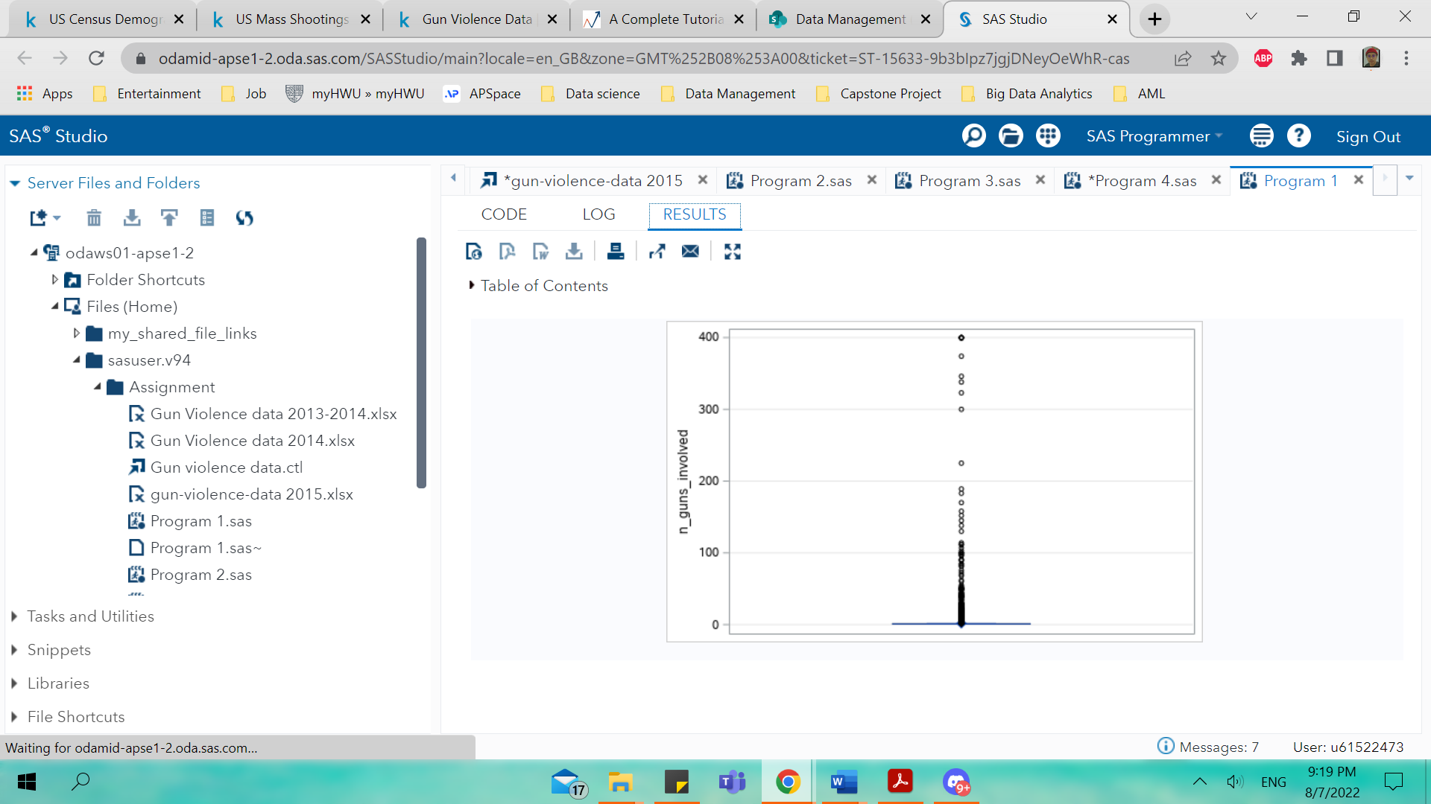

Figure

The next section is discussion of histogram to see the distributions of the variables. The main objective of histogram is to graphically sum up the distribution of univariate data set and again the same step where comparison is made for histogram about datasets on 2014- and 2015-gun violence data.

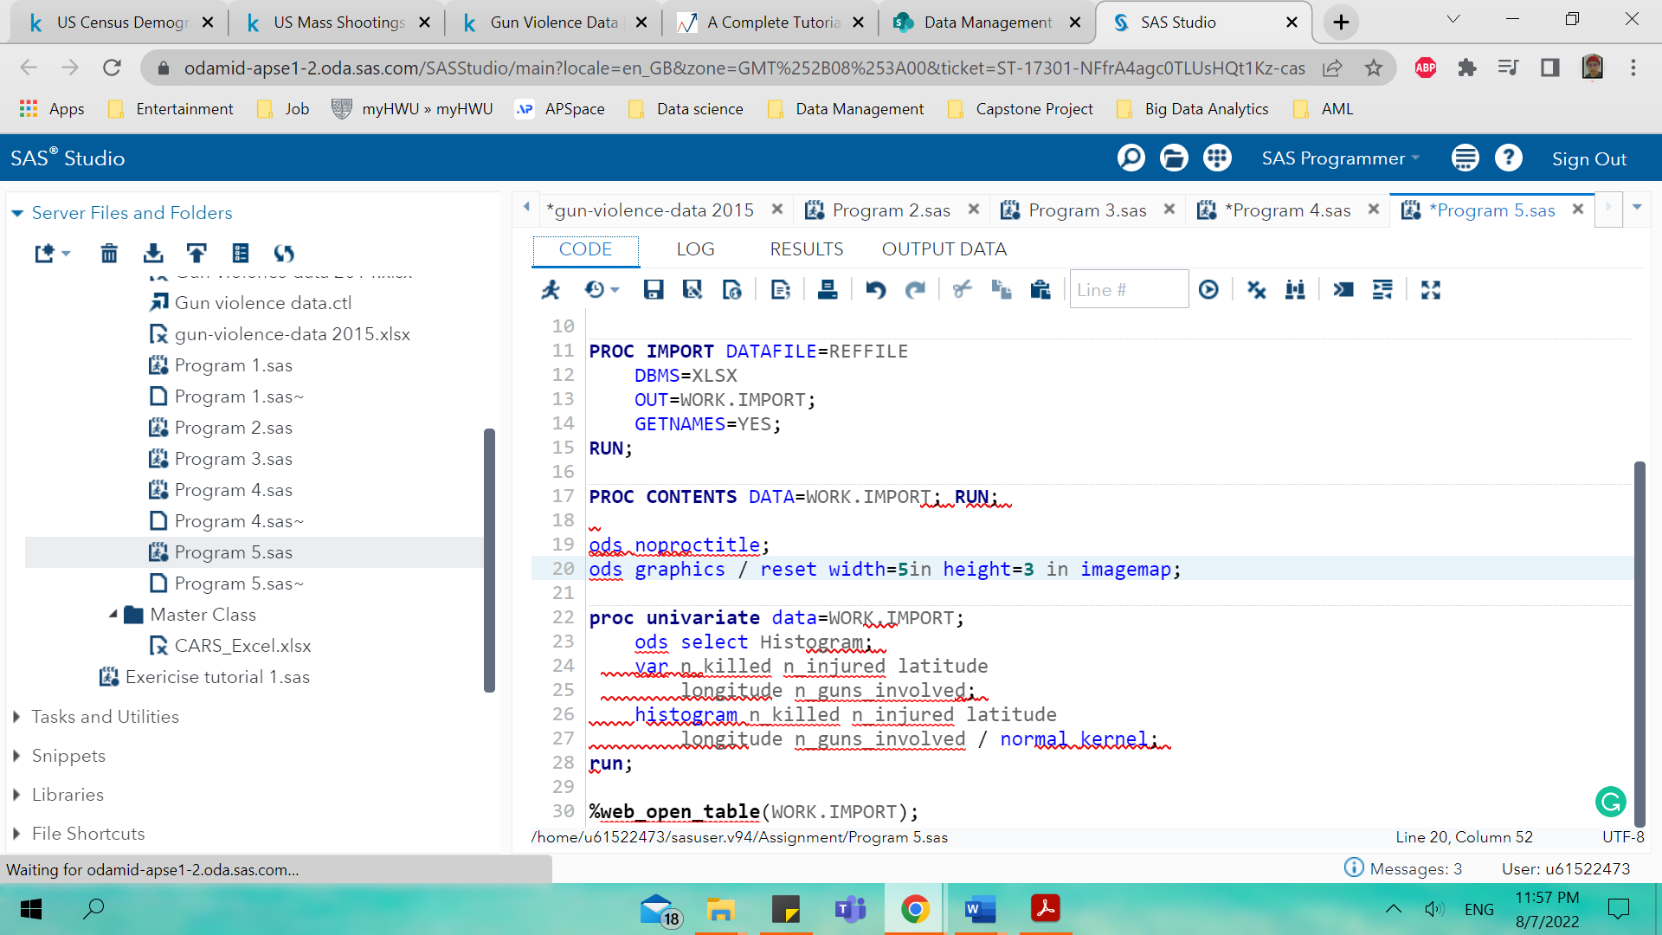

Figure

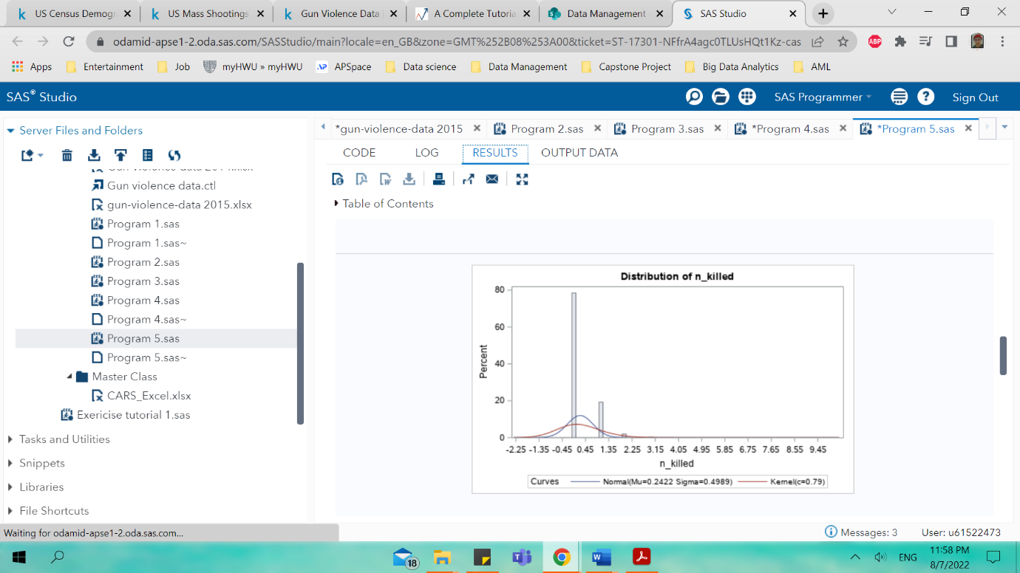 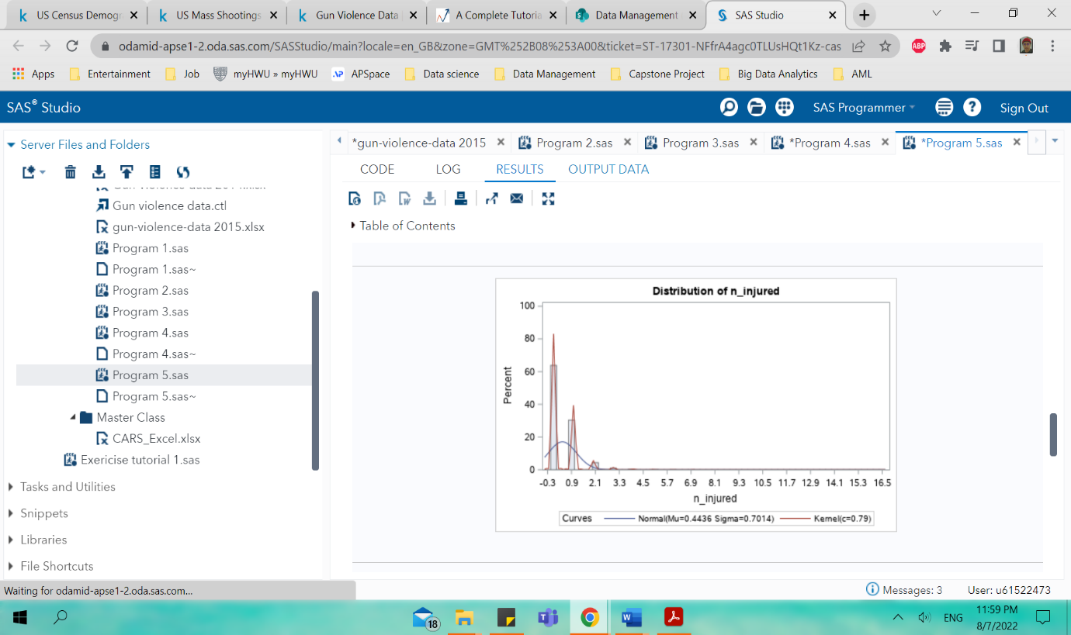 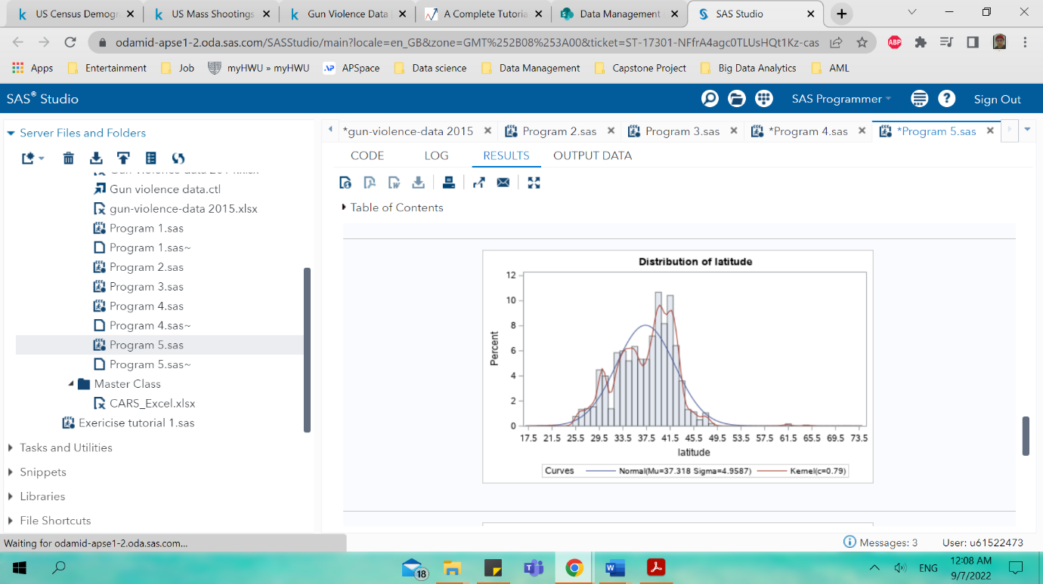 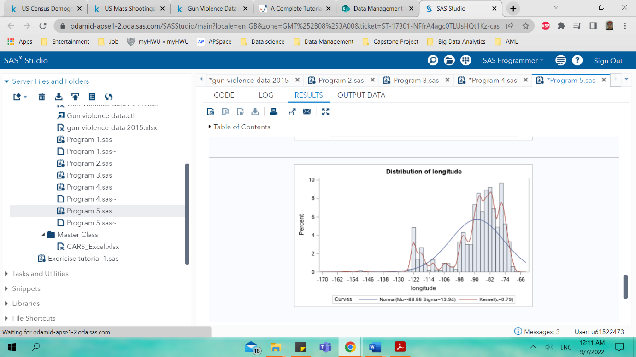

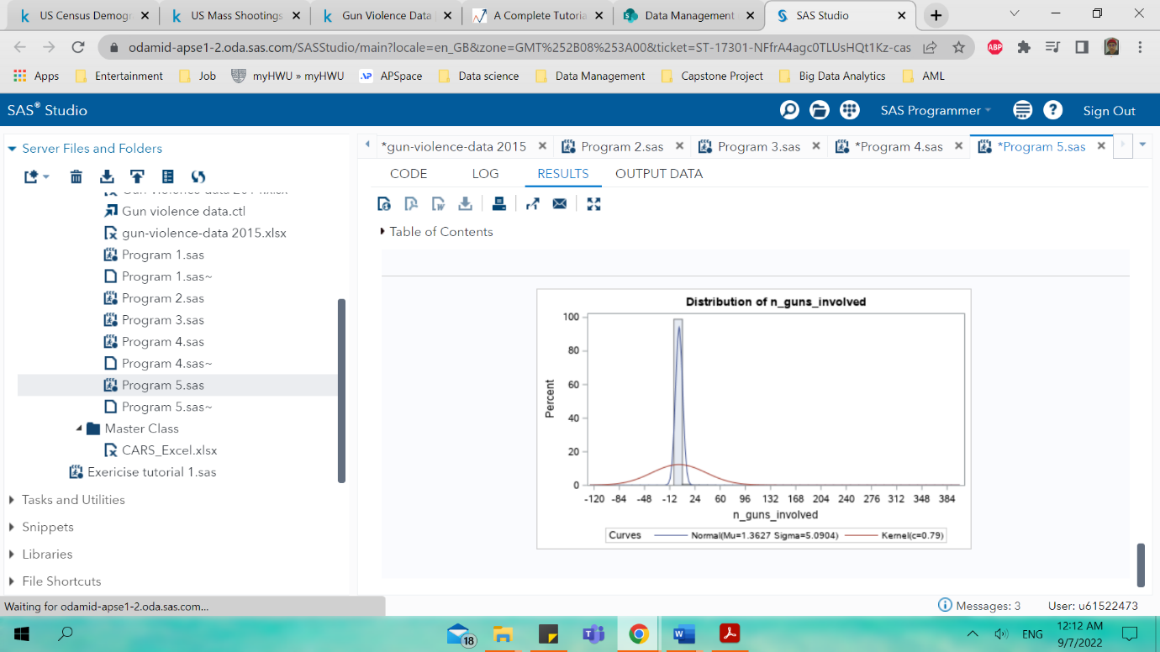

Figure 23 shows the SAS code for 2014-gun violence datasets and below it is the distribution of the histogram variables for the 2014-gun violence datasets. The same method is applied to the 2015 datasets and the histogram for the 2015-gun violence datasets is shown below.

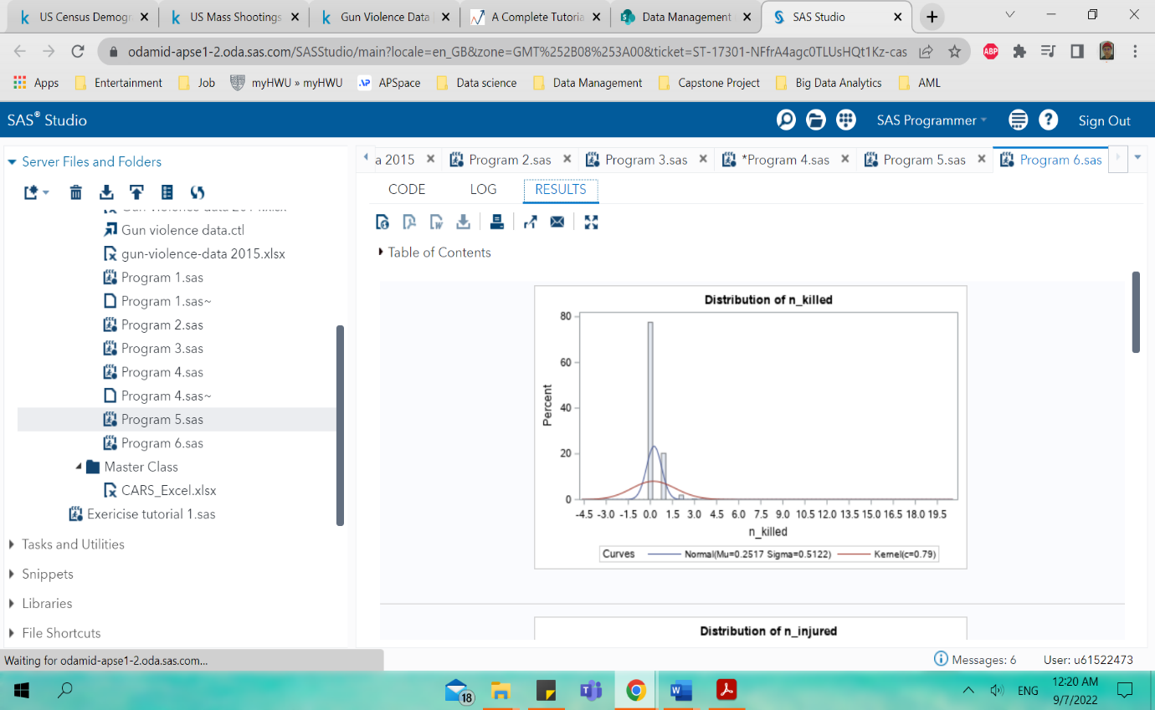 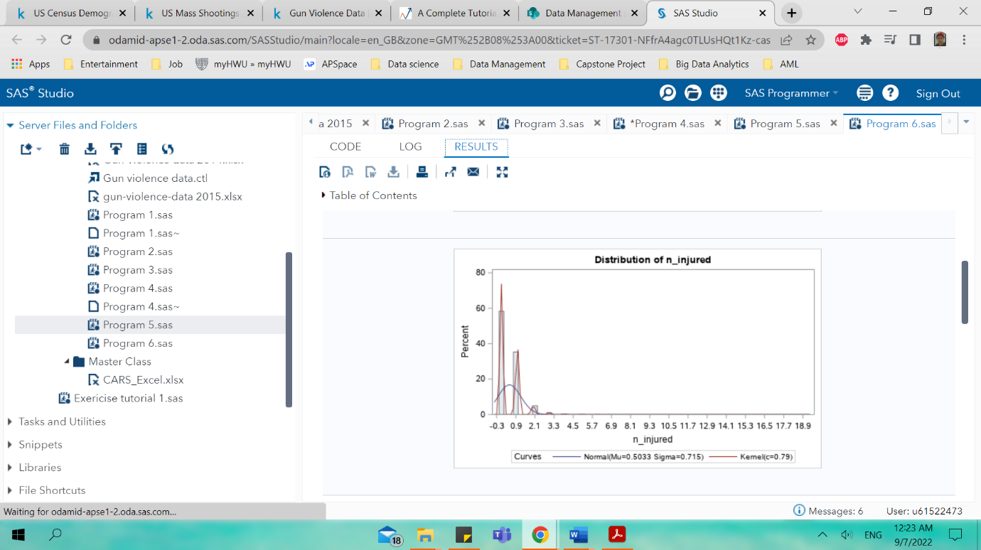

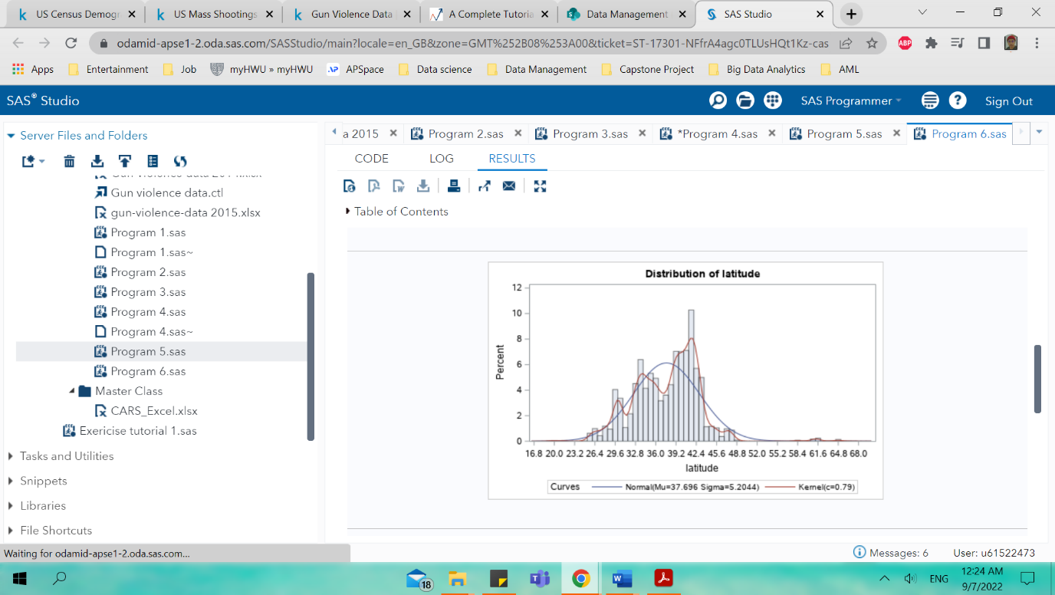 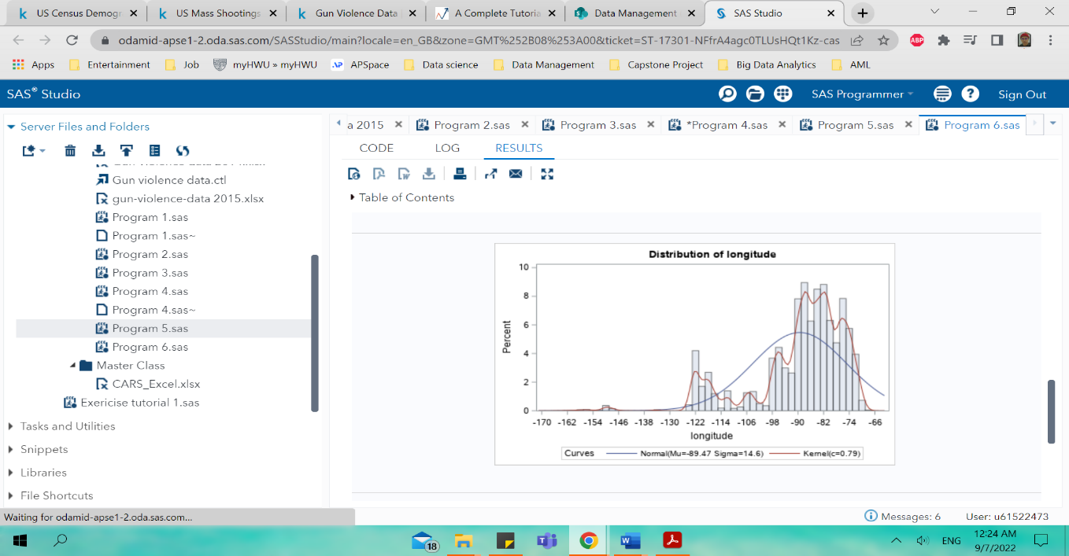

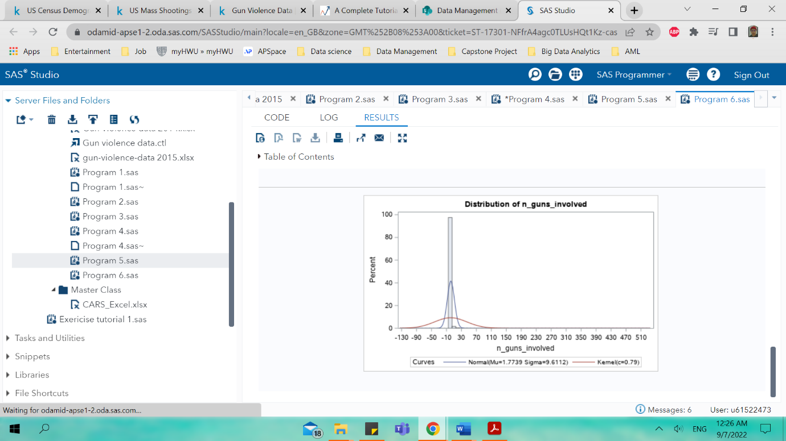

**Data Pre-processing**

In this part it is required to investigate the method to handle the incomplete, noisy and inconsistent data and the applied technique is further explained in this section here. In this section the method of handling the noisy data my removing the features or instances is not allowed in this assignment and thus another technique should be explored.

Before going into the details of the technique data pre-processing is a part of data preparation where its transforming raw data into useful data. In a traditional data pre-processing is an introduction step before data mining process and distinct ways are used in data pre-processing. These tools are sampling, transformation, denoising, imputation, normalization and feature extraction. In this assignment normalization and imputation method are used for the data pre-processing.

1. **Imputation**

The SAS code below shows the imputation SAS code where the median data is used for the variables. This part here is the section for the 2014-gun violence datasets and it can be viewed on figure 27 and 30 the missing data frequencies values

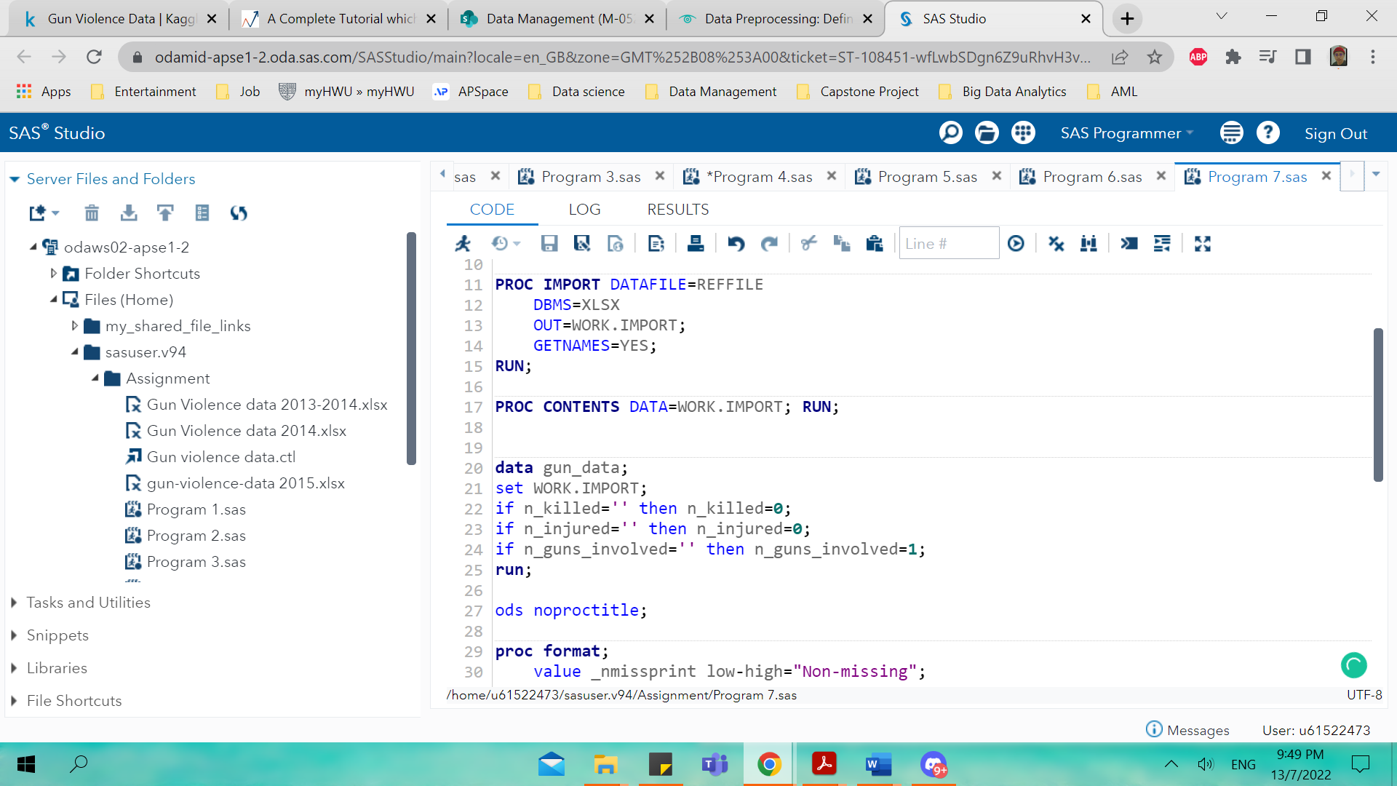

Figure

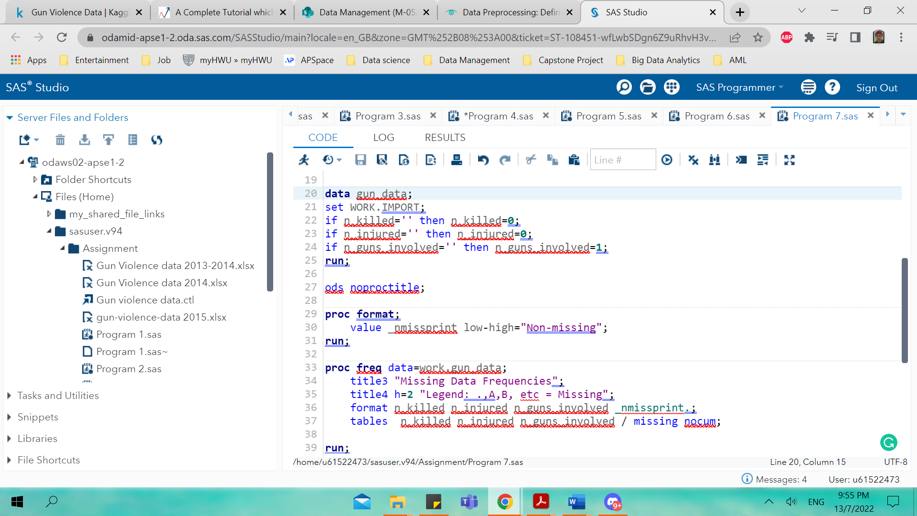

Figure

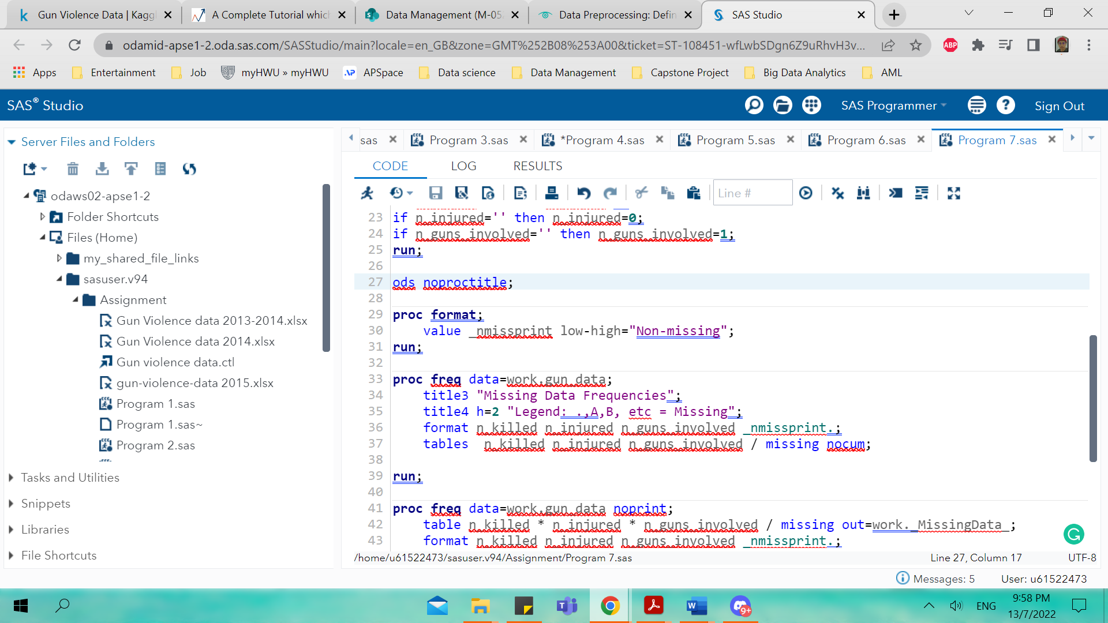

Figure

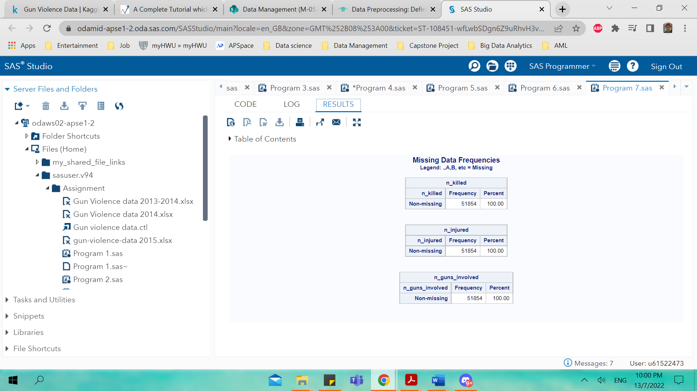

Figure

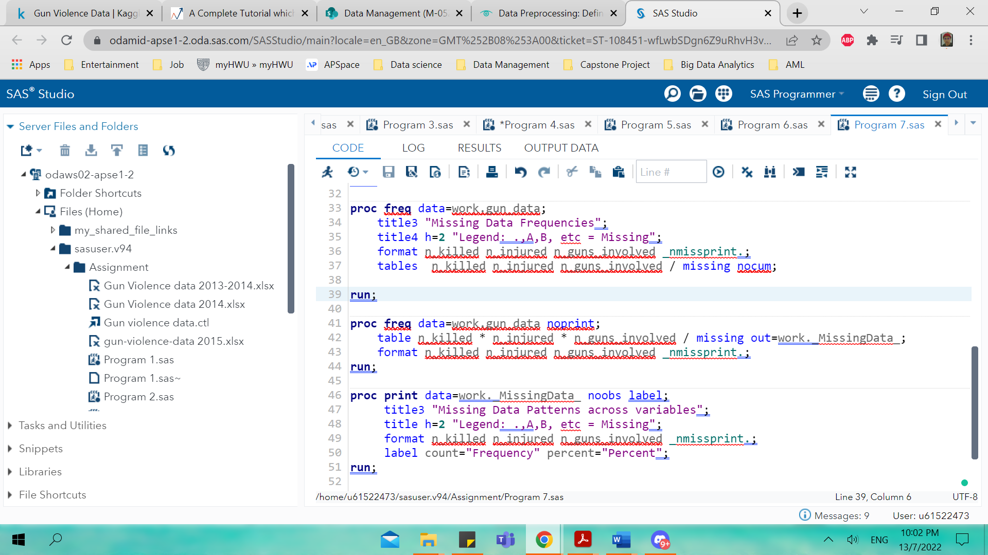

Figure

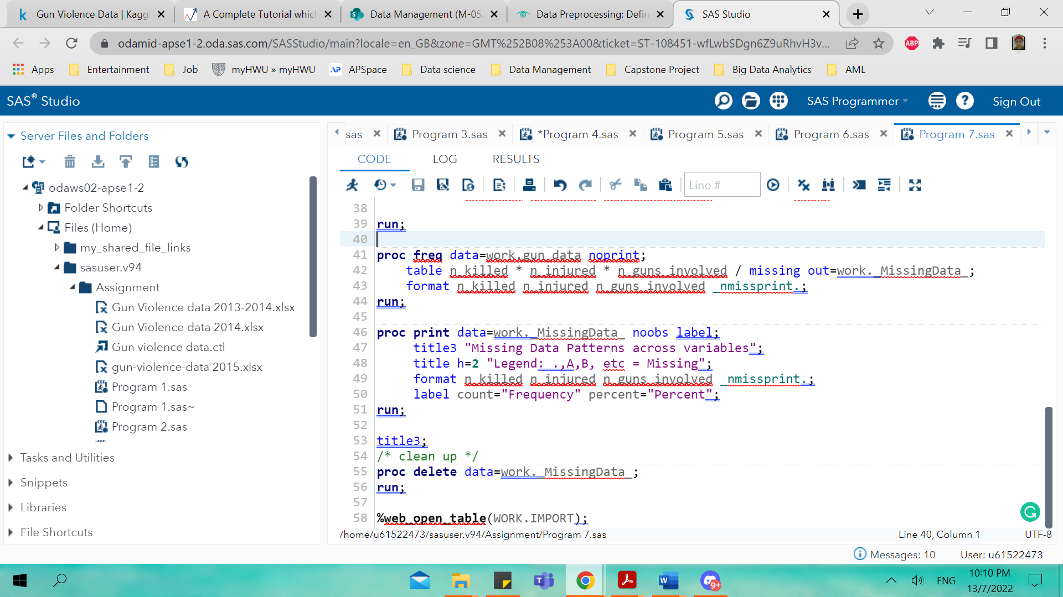

Figure

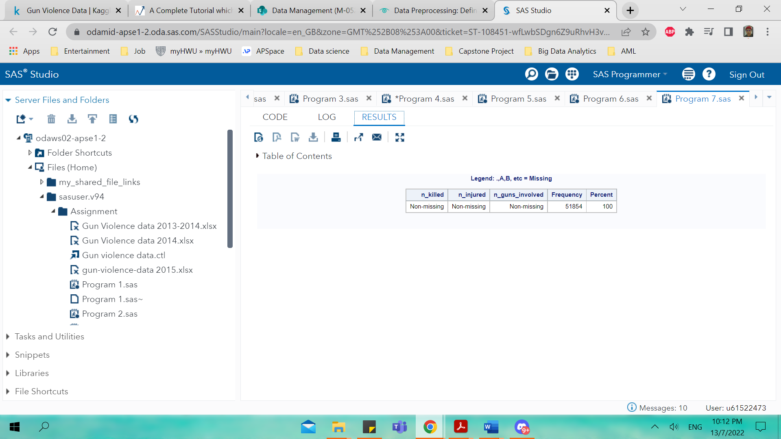

Figure

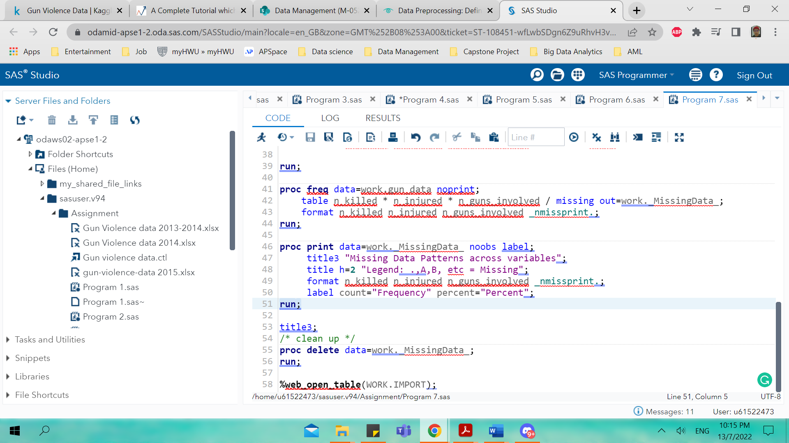

Figure

This part here discussing the section of 2015-gun violence datasets for imputation SAS code for the missing values. The same method for SAS code for 2015- gun violence is applied here from the SAS code used in 2014 gun-violence datasets as shown in figure 24,25,26,28,29 and 31. Figure 32 and 33 indicates the missing data frequencies for the 2015 datasets.

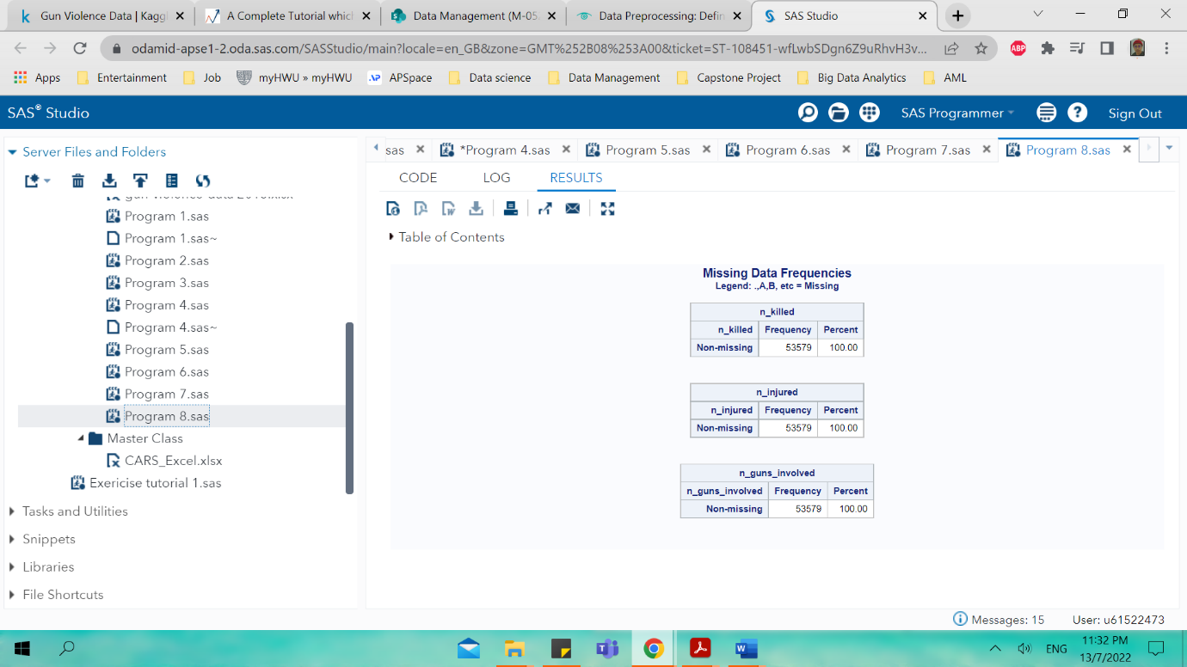

Figure

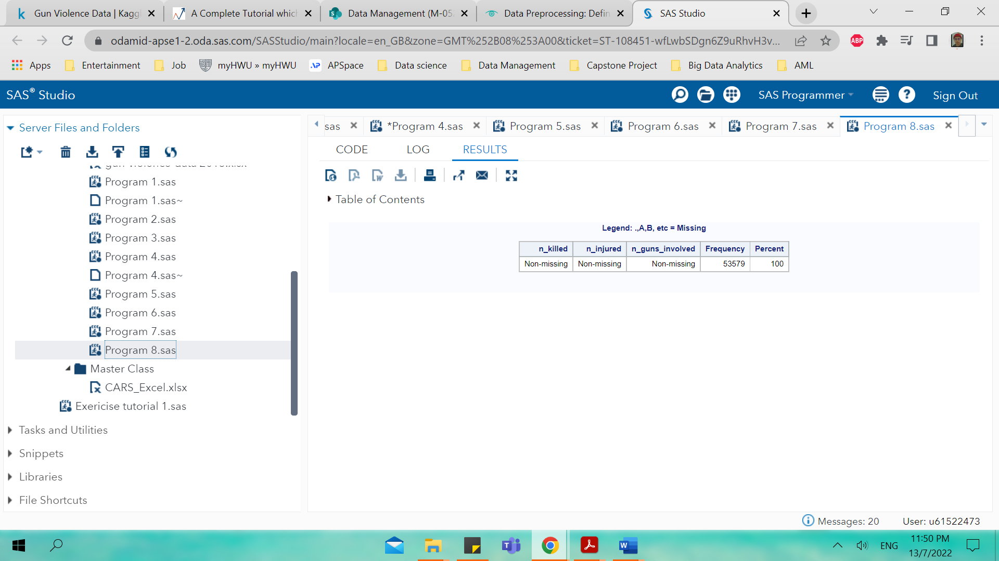

Figure

The tables indicates that by using this imputation method there will be nor more missing values indicated by the imputation method.

1. **Normalization**

In figure 34 below it shows the code to normalized the data and as for this code it is applied for both 2014 and 2015.

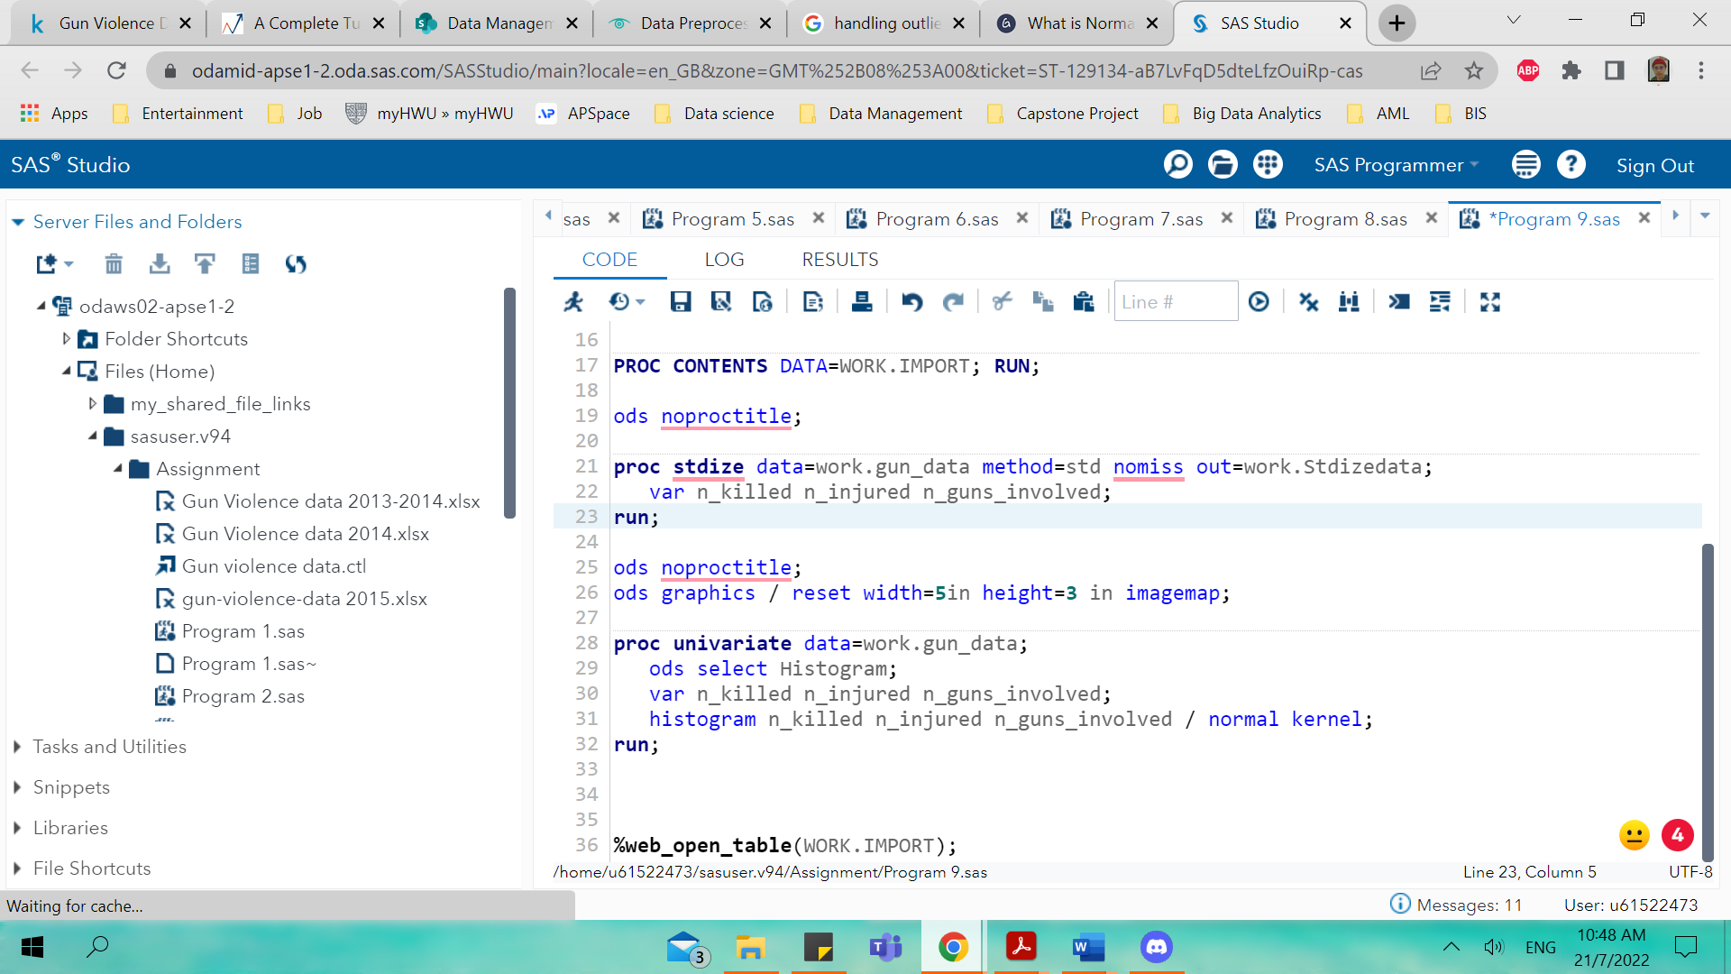

Figure

The three figures below show the 2014- gun violence datasets histogram where three variables are selected such as n_killed, n_injured and n_guns_involved.

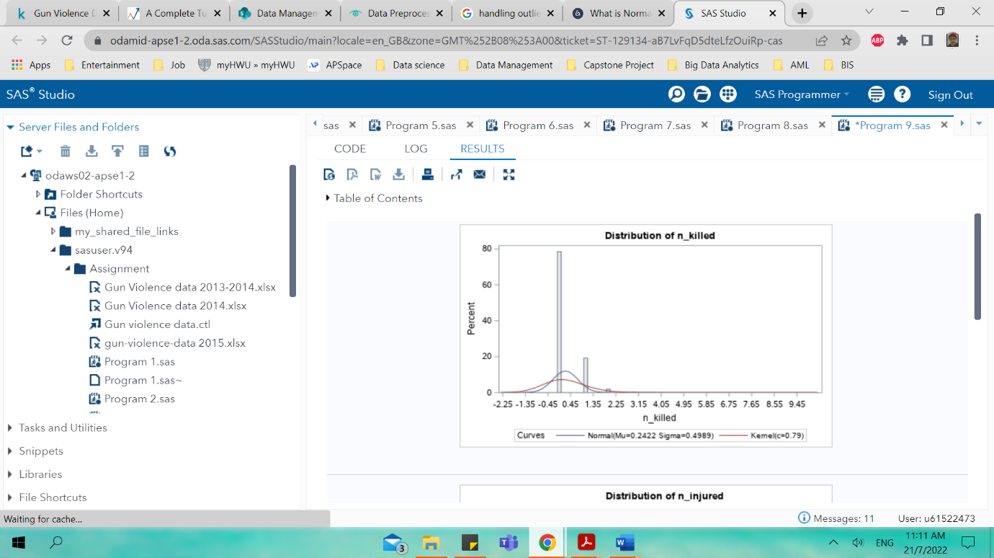

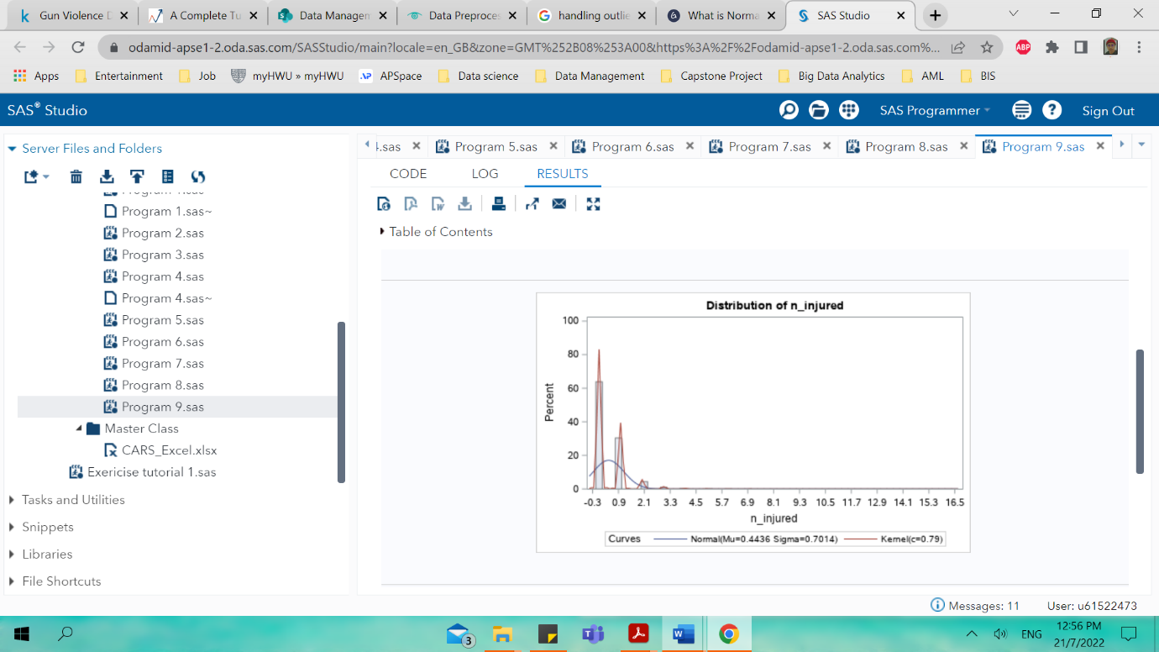

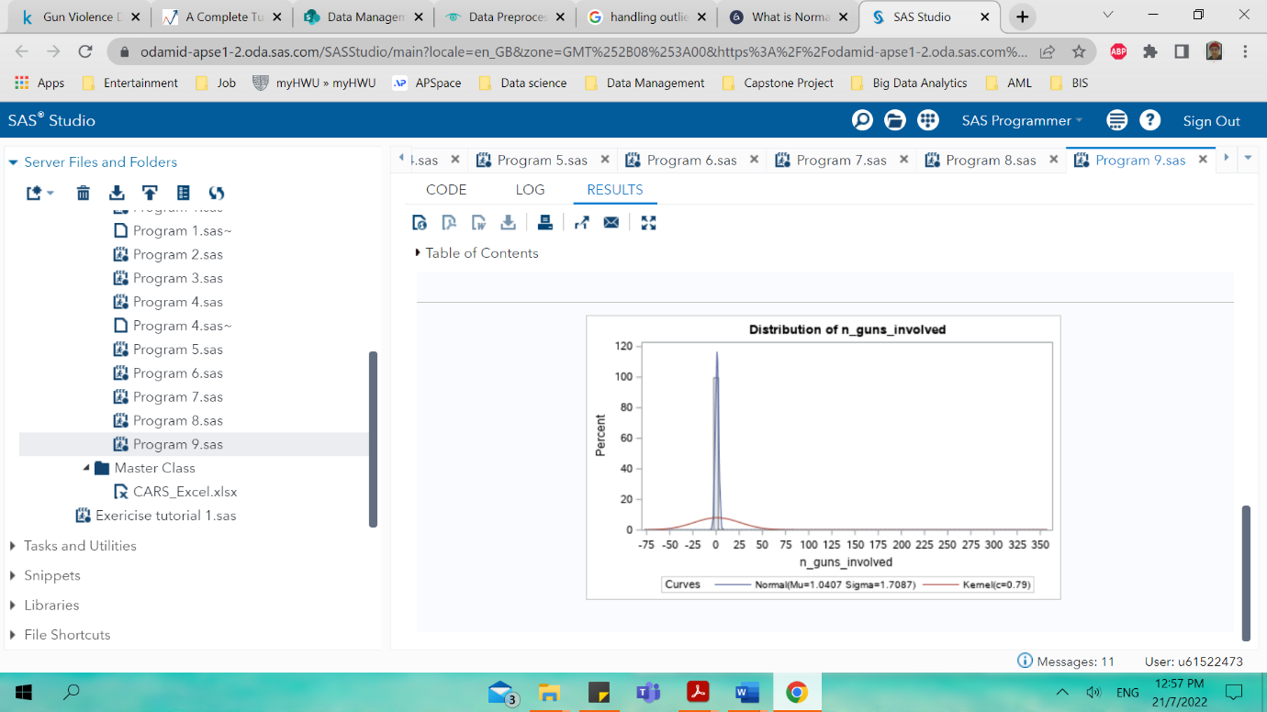

The three figure below on the other hand is the histogram visualization for the 2015-gun violence datasets.

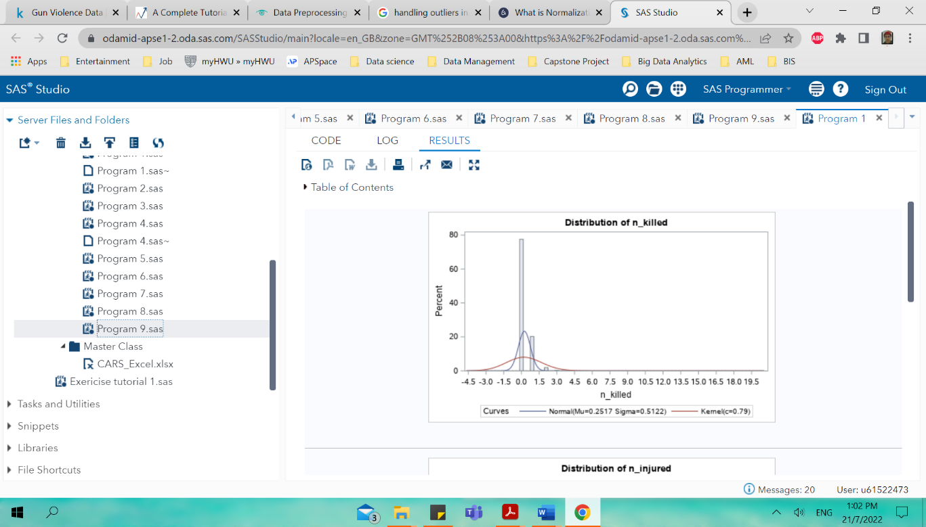

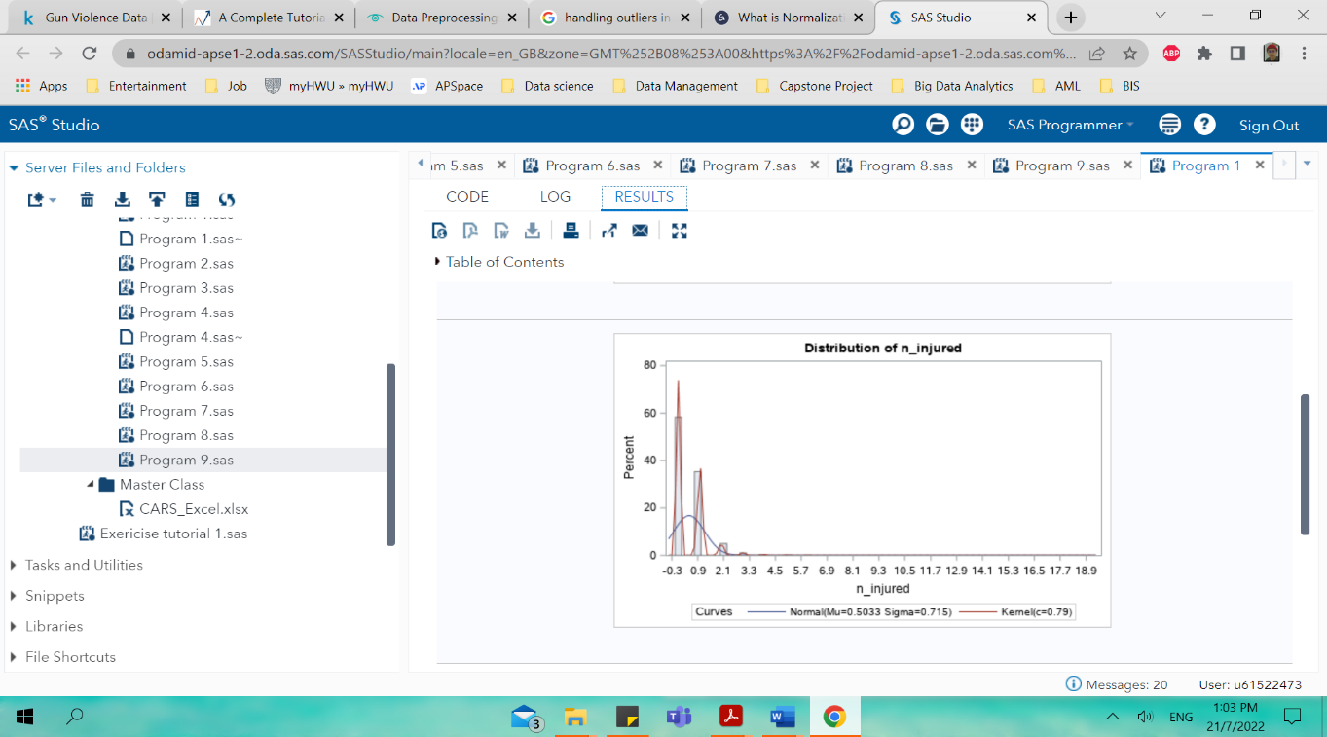

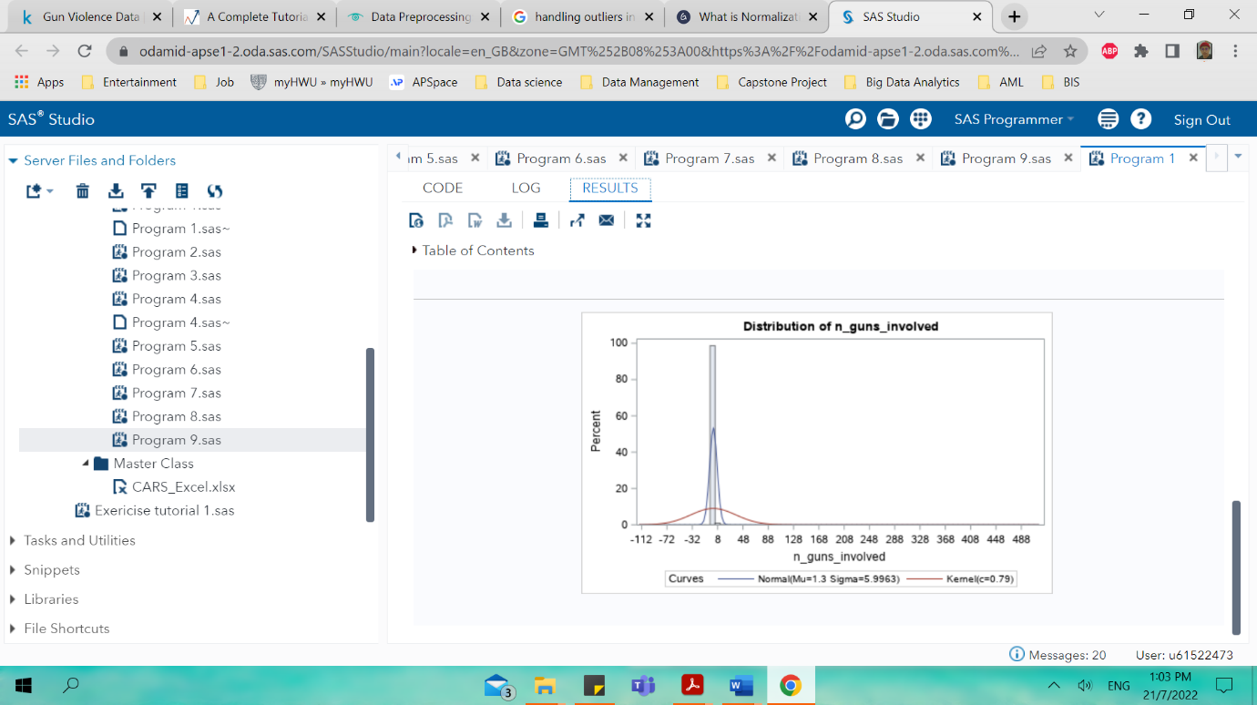

**Feature engineering**

It is a process of selecting, manipulating, and converting raw data into features that can be implemented in supervised learning. It is a machine learning technique that leverage data to create new variables that are not available in training set. The main goal is to simplify and fastening up the data transformations and the same time increases model accuracy.

Logarithm transformation is one of the most commonly used mathematical transformations in feature engineering whereby it is used to handle skewed data and hence after the transformation, the data distribution becomes really close to normal. The code in figure 35 below shows the SAS code use for log transformation and hence the following part shows the histogram distribution of the 2014- and 2015-gun violence datasets where it is becoming less skewed compare without feature engineering/ log transformation.

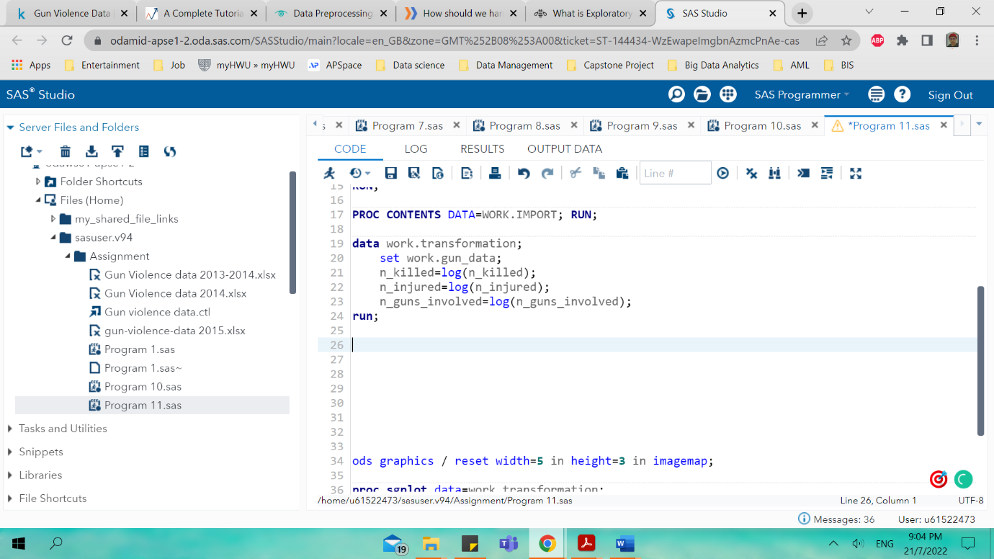

Figure

The three figure below shows the histogram distribution of the variables after undergoing log transformation

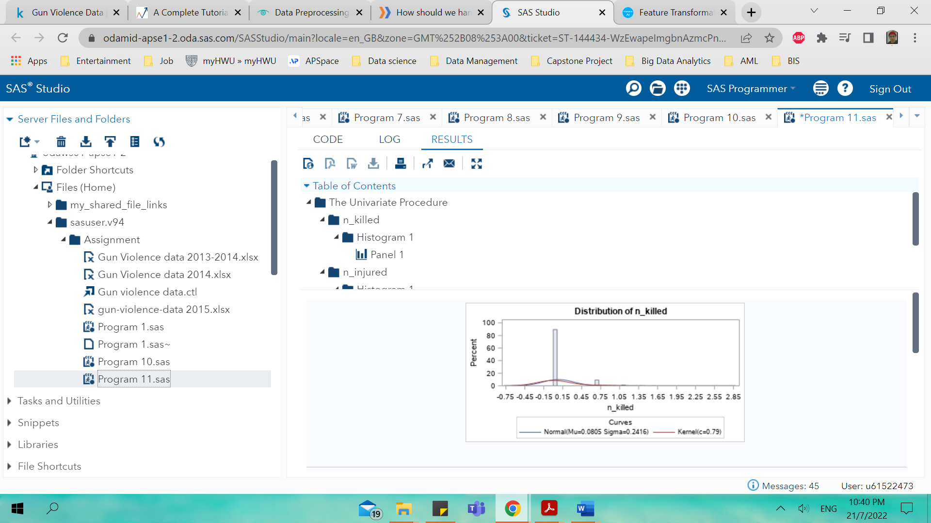

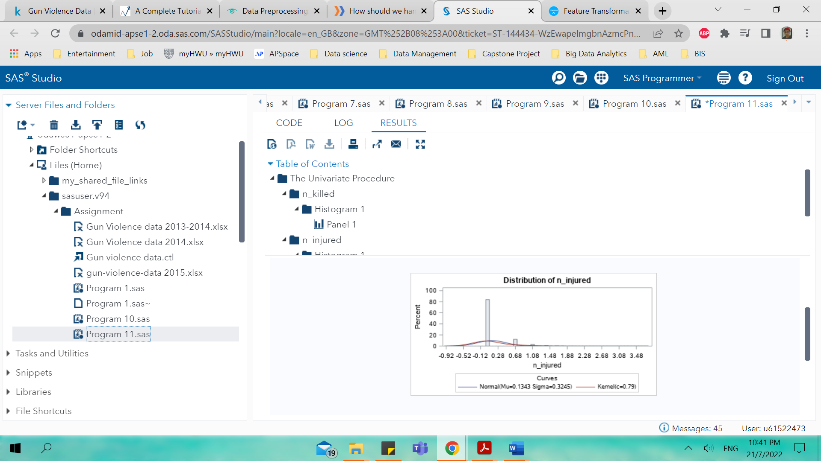

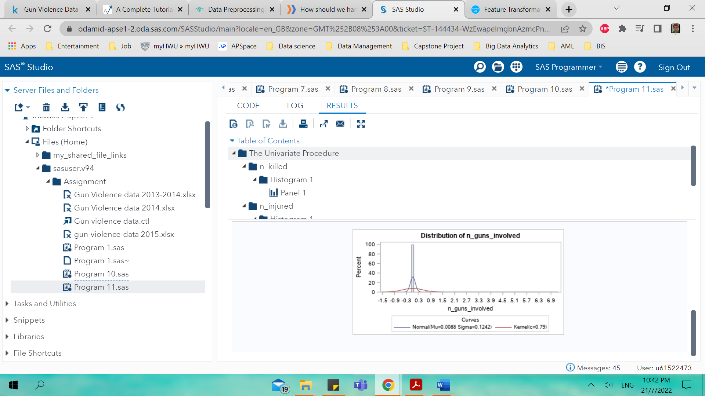

The three figures below show the log transformation histogram distribution for the 2015 datasets

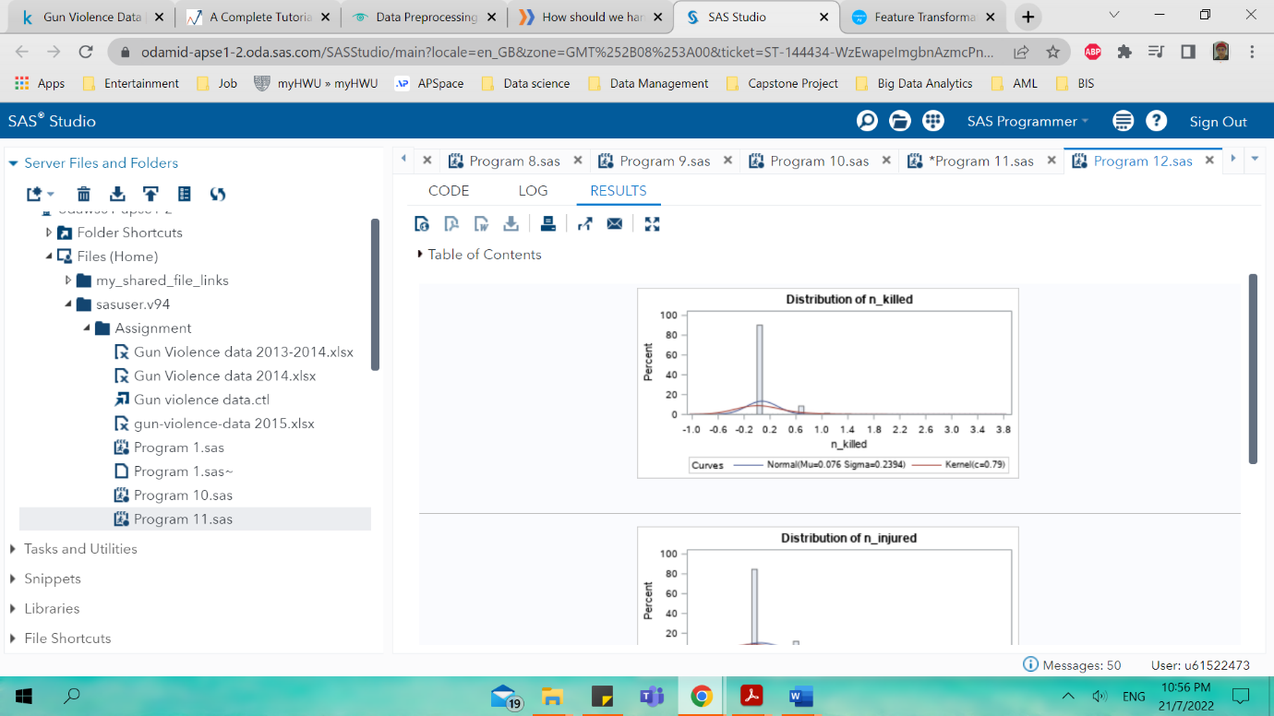

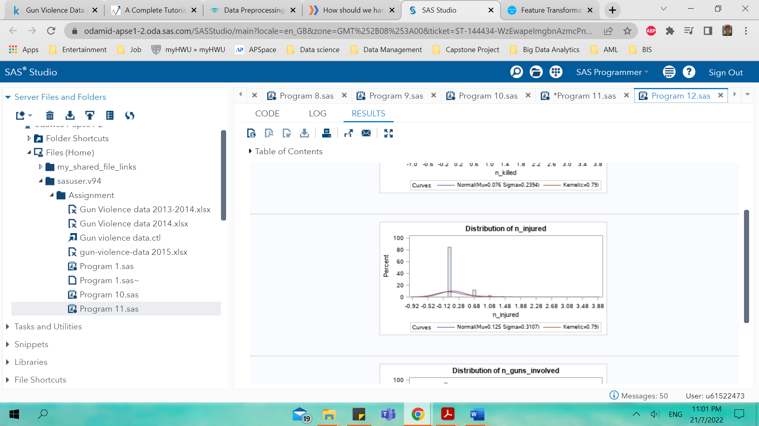

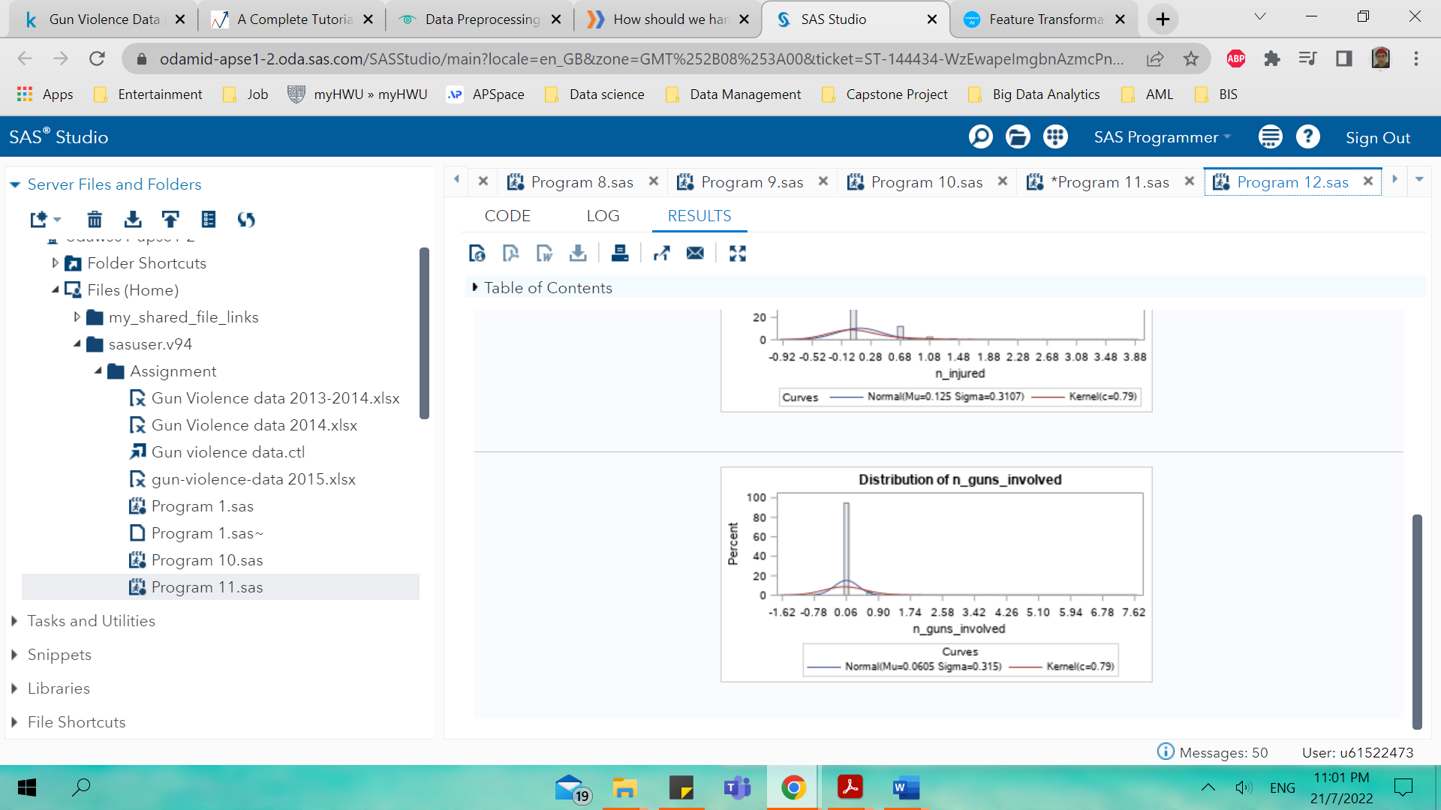

**Exploratory Data Analysis (EDA)**

Exploratory data analysis main function is to help look at data before making assumptions where it can be use to detect any errors such as understanding better and well about the data patterns, identify outliers, and find relationship between the variables. There are several exploratory data analysis tools such as clustering and dimension reduction, univariate, bivariate, multivariate visualizations, k- means clustering and predictive models.

Figure 36 shows the SAS code for the scatter plot with the heatmap and correlation with the regression line at it shows that there is a relationship between n_guns_involved and n_killed based on the scatter plot in figure 37 as the number of guns involved increases the number of killed people is increasing as well.

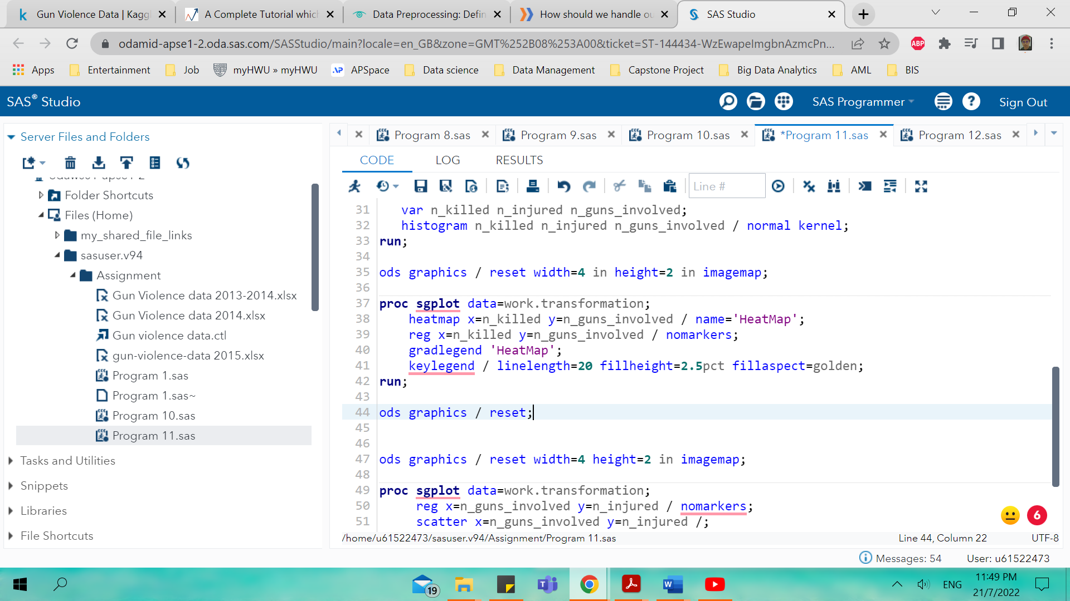

Figure

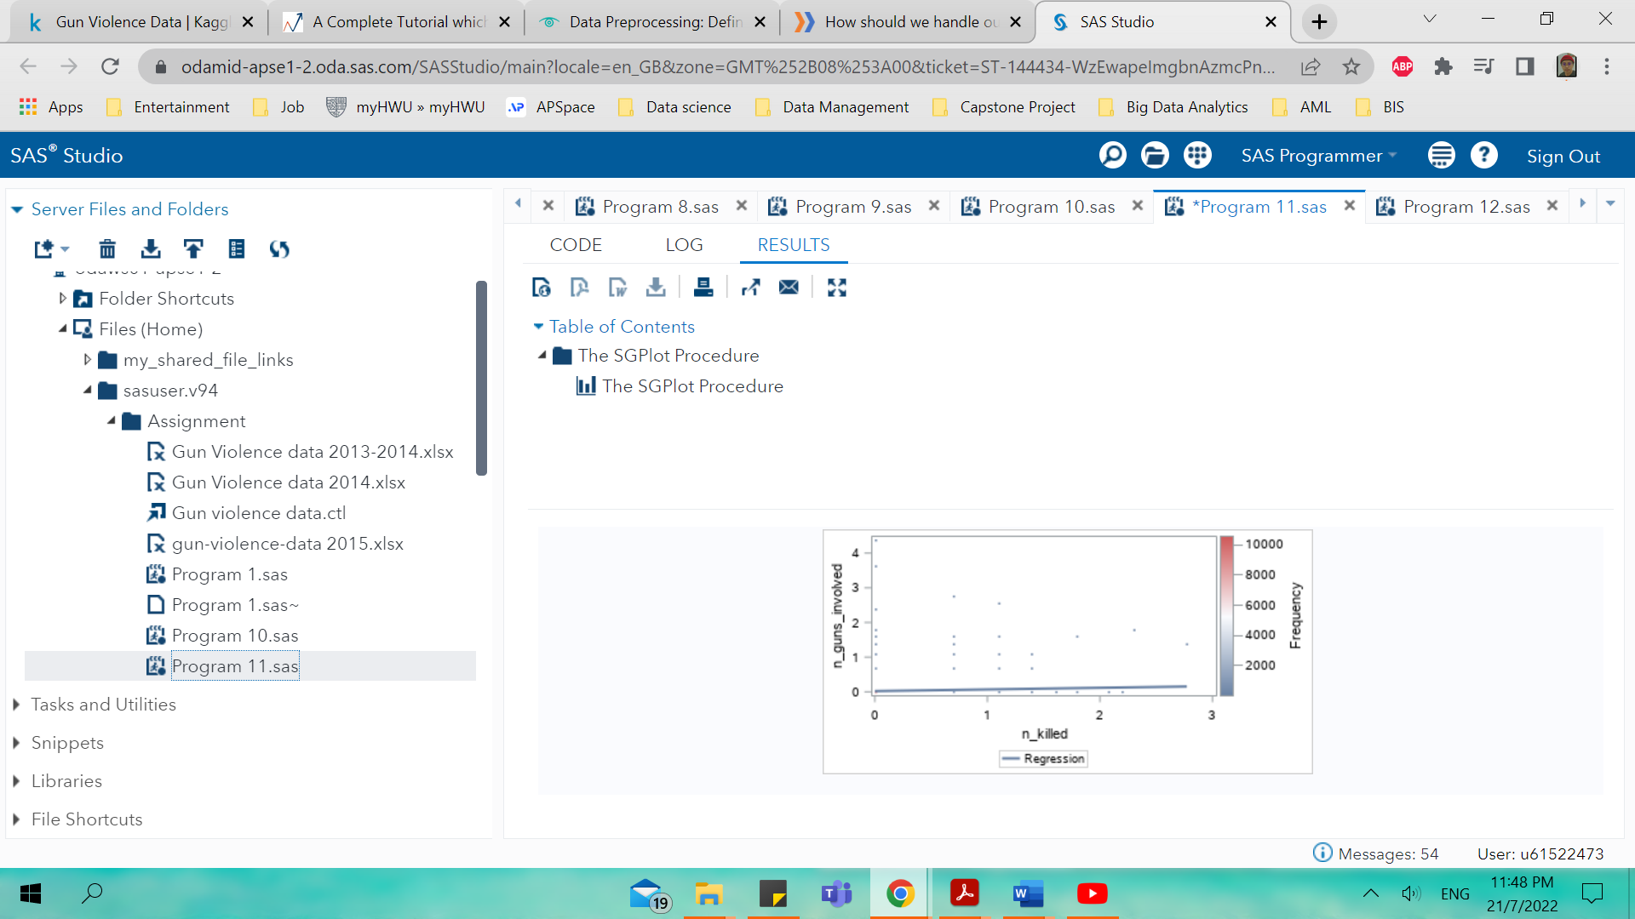

Figure

Figure 38 shows the SAS code that explained figure 39 whereby it shows that there is a relationship between n_guns_involved and n_injured where by as the number of guns involved increases the number of people injured increases.

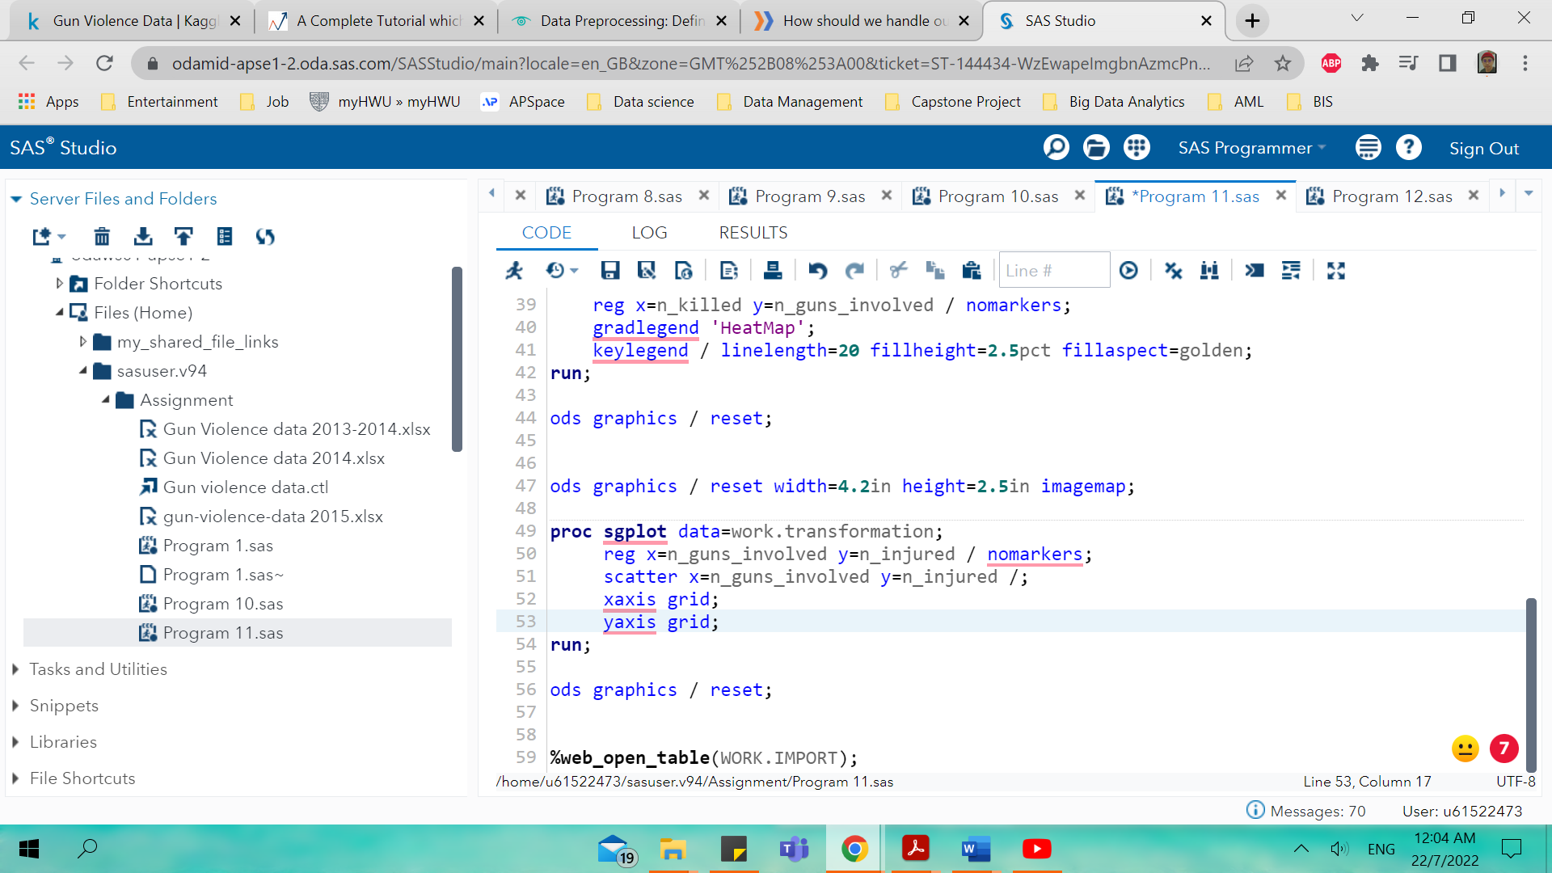

Figure

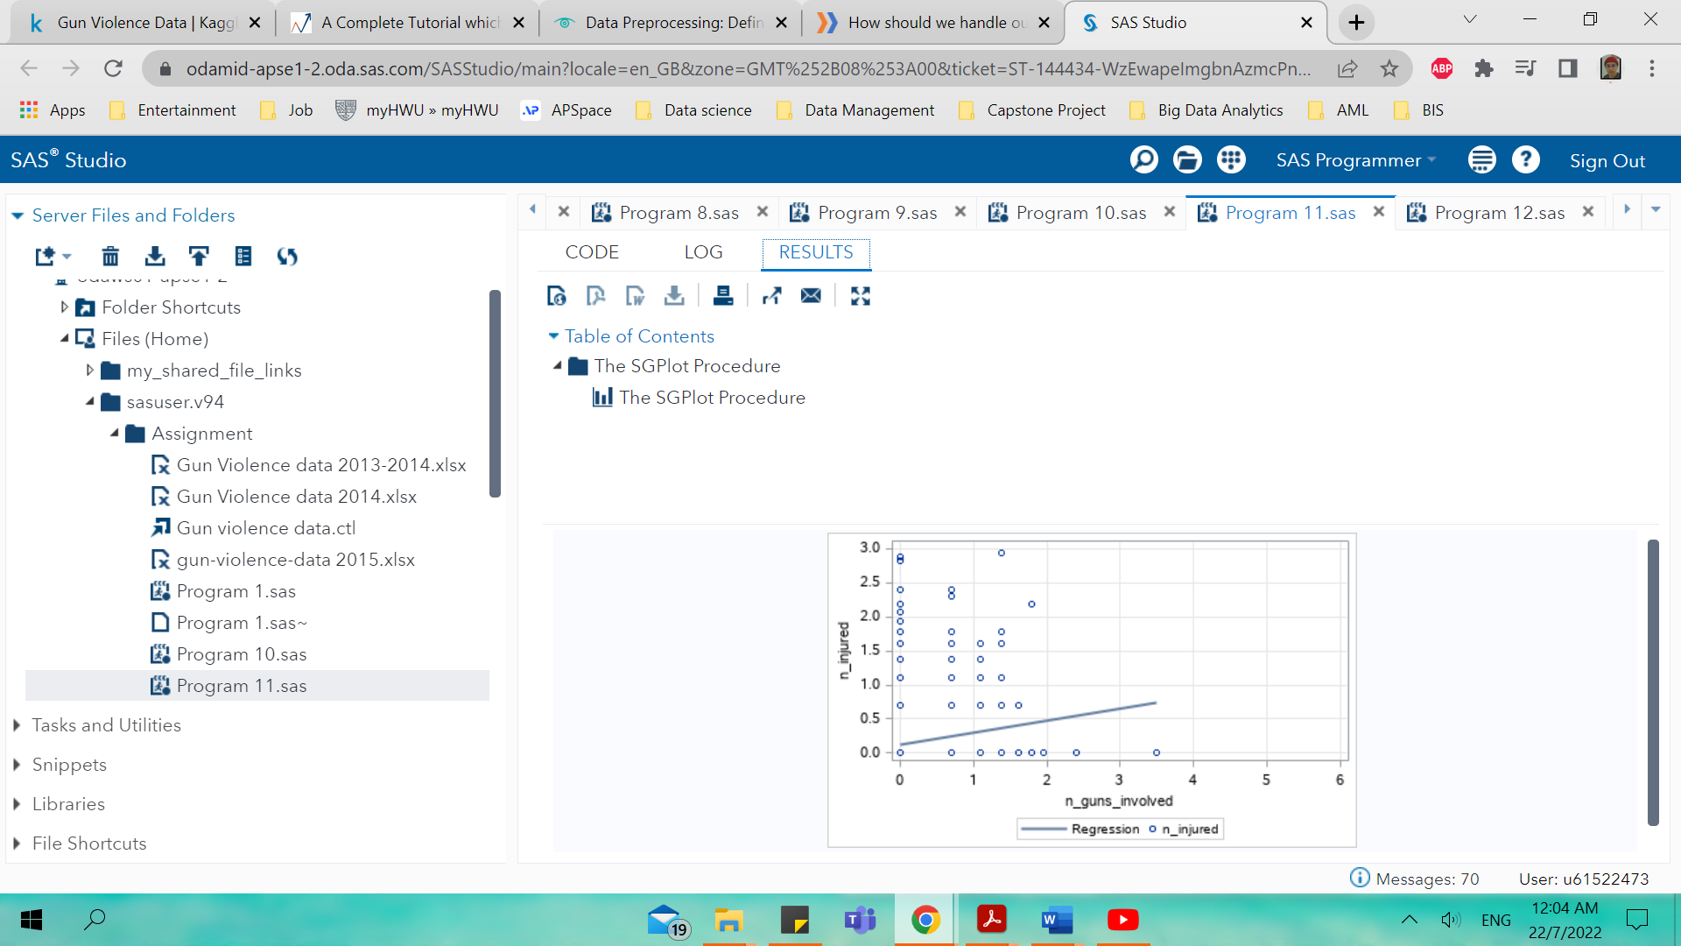

Figure

Figure 40 shows the SAS code for the pearson correlation whereby the target variable used is number of guns involved and table 7 shows the coefficients relationship between n_guns_involved and other numerical variables from the datasets.

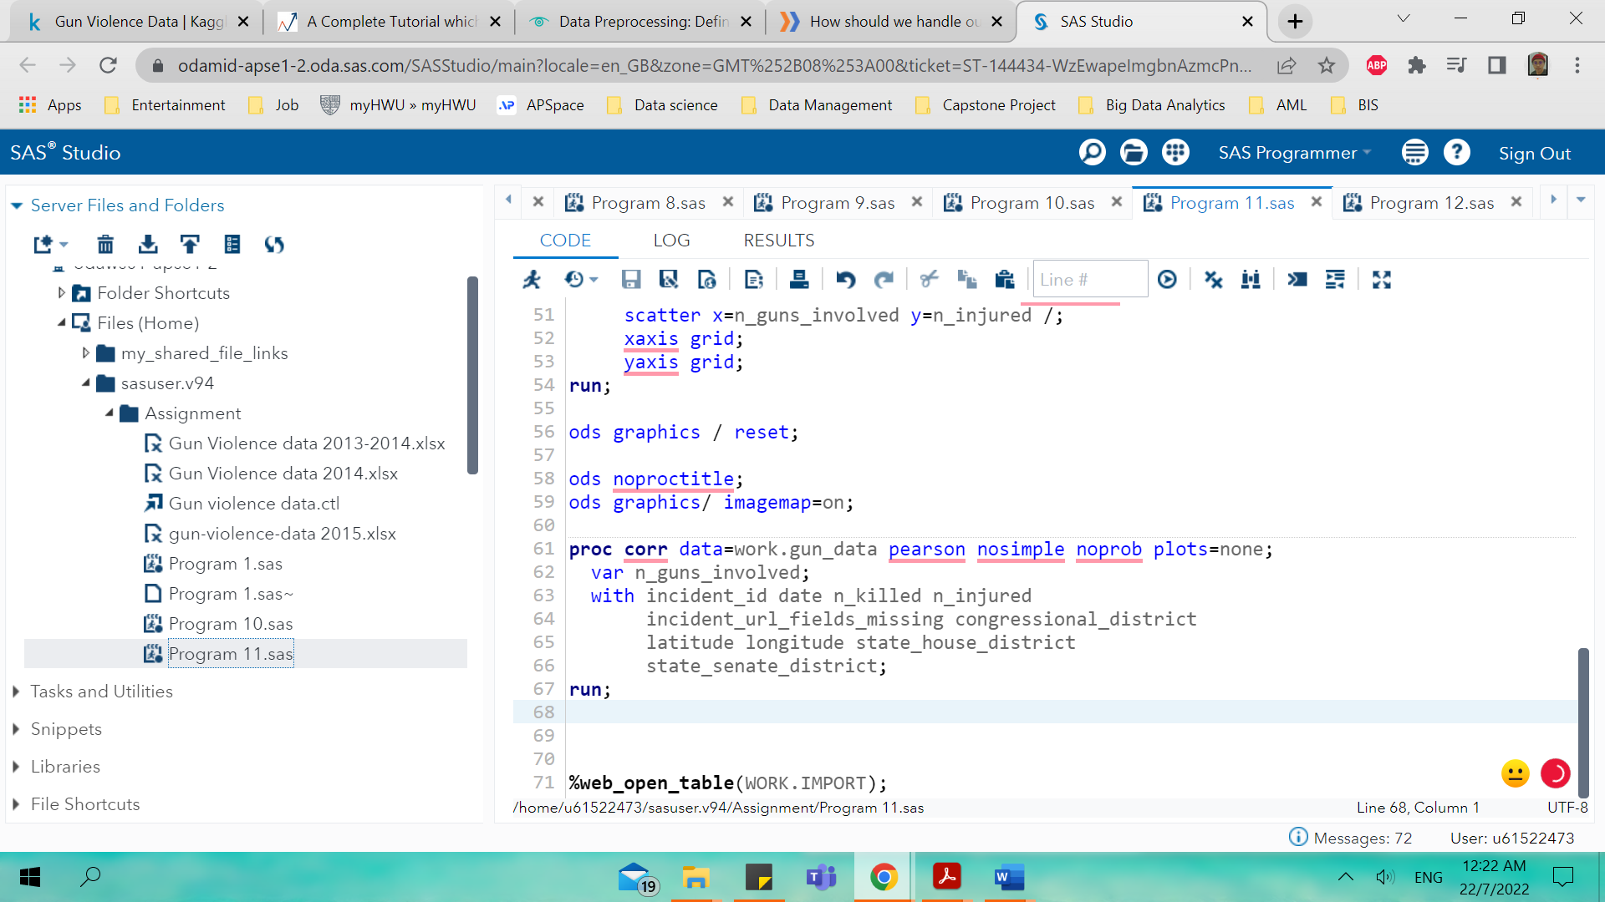

Figure

|  |  |
| --- | --- |
| **10 With Variables:** | incident_id date n_killed n_injured incident_url_fields_missing congressional_district latitude longitude state_house_district state_senate_district |
| **1 Variables:** | n_guns_involved |

Table

| **Pearson Correlation Coefficients Number of Observations** | |
| --- | --- |
|  | **n_guns_involved** |
| **incident_id** | 0.01420  53579 |
| **date** | 0.01012  53579 |
| **n_killed** | -0.01946  53579 |
| **n_injured** | -0.03039  53579 |
| **incident_url_fields_missing** | .  53579 |
| **congressional_district** | 0.02078  53114 |
| **latitude** | -0.00354  53148 |
| **longitude** | -0.01529  53148 |
| **state_house_district** | -0.01041  46941 |
| **state_senate_district** | -0.00069  48004 |

From the table 7 it shows that there is high negative correlation between the target variables which number of guns involved with the number of people killed at -0.01946 and number of people injured at -0.03039 and for the rest there is no relationship between the rest variables.

**Hypothesis**

Thus, it can be said that from the cleaned and transform datasets several hypotheses can be derived from the visualization done on the previous section with data visualization using SAS studio. The list below 5 interpretations of hypotheses of this dataset using the SAS studio Codes.

* The variable is grouped into categorical and continuous
* The detail explanation of descriptive statistics
* Imputation can be used to get missing data values
* Normalization is used to standardized the data
* Log transformation is used to make the datasets distribution less skewed

# **Discussion**

This part explained the detail explanation of all the process starting from the initial data exploration, data pre-processing, exploratory data analysis and hypothesis about the summary of the findings. These parts consist of details explanation about the specific traits or values of certian attributes from the datasets imported into the SAS, extracting relevant insights or information from the distributions, finding out any correlation between the variables and more. In this assignment it the datasets used is from Kaggle about gun violence where it has range of data from 2013-2018 but for the purpose of this assignment only 2014- and 2015-gun violence datasets are used for data analysis.

For initial data exploration the output of the SAS code shows 52133 observations and 29 attributes or variables. Then the data is categorized into categorical and continuous where there is 18 Char data type and 11 Num data type. After categorizing the data, descriptive statistics can be done to show and summarize basic features of the gun violence datasets where it is presented to describe the data sample and the measurements. For example, WORK.IMPORT1; are used for most of the analysis to get the desired output such as the values of mean, distributions, medians, variances, percentiles, standard deviation, N Miss.

Next there is a comparison between two different years of the gun violence datasets used where observations number of 2014 datasets are 51854 whereas 2015 is 53579 and it can be concluded in the initial data exploration the 2015-gun violence datasets shows much higher values for most of the variables such n_killed, n_injured, latitude, longitude and n_guns_involved for its mean, standard deviation, minimum, maximum, median, N, N Miss and quartile range. The next section is the data visualization using boxplot and histogram whereby both 2014 and 2015 datasets are already explained in the initial data exploration part. After that, histogram is used to study the distributions of the variables and the variables selected are n_killed, n_injured, latitude, longitude and n_guns_involved because its numeric variable. The mean value distribution for 2014 mu is 0.2422 meanwhile for 2015 is 0.2517 for number of people killed and it shows the higher value of mu indicates the data is more spread out for the 2015 one. For the 2015 number of people injured mu value is 0.5033 which is higher than 2014 at 0.4436 meanwhile it is also higher in 2015 where the mu value is 1.7739 whereas in 2014 is 1.3627.

Next is data pre-processing where two methods proposed that is imputation and normalization and the main function of data pre-processing is to handle noisy data. Imputation is done for both 2014- and 2015-gun violence datasets where only three variables are selected and in 2015 the number of frequencies is 53579 and 2014 is 51854. The second part of data pre-processing where the datasets is normalized and standardized. After that is feature engineering where log transformation is applied for both 2014 and 2015 datasets. It is found that mu value is changing and this indicates that the data becomes less skewed and it is found that mu in 2014 for n_killed is higher at 0.0805 than 2015 at 0.076 for histogram distribution. For the number of people injured the mu value in 2014 is 0.1343 meanwhile in 2015 is 0.125 and number of guns involved in 2014 is 0.0088 while in 2015 is 0.0605. This shows that after log transformation the data is more spread in 2014 than 2015.

For exploratory data analysis scatter plot is used to show the correlation between the variables and as number of guns increases the number of people killed also increases. This same goes with number of people injured and number of guns involved where it shows linear trend or relationship.

# **Conclusion**

It can be concluded that gun violence datasets obtain from Kaggle about Gun Violence in United States from 2013-2018 shows ample and significant discussion for this assignment. It can be concluded there is a significance difference on the output results of SAS code for both year 2014 and 2015. The results of the analysis shows that 2015 has significant results as compare to 2014 and can be deduced that as number of observations increases it provides more insights on the data analysis. From the variables point of view as the number of guns involved increases the number of death and injuries increases and thus much stricter gun control is needed in USA to reduce more death and injuries related to gun violence especially mass shootings.

# **References**

Krouse, William J., and Daniel J. Richardson, Mass Murder with Firearms: Incidents and Victims, 1999–2013, Washington, D.C.: Congressional Research Service, R44126, 2015.

Duwe, Grant, “Patterns and Prevalence of Lethal Mass Violence,” Criminology and Public Policy, Vol. 19, No. 1, 2020, pp. 17–35.

CDC WONDER Online Database. Data are from the Multiple Cause of Death Files, 1999-2022. Accessed at http://wonder.cdc.gov/mcd-icd10.html on Jun 20, 202 Maps developed in SPSS 28 by Federico G de Cosío

Everytown. The Economic Cost of Gun Violence. Everytown Research & Policy. Feb 17, 2021. Consulted on June 24, 2022. Available at: <https://everytownresearch.org/report/the-economic-cost-of-gun-violence/>.

Ressler, Robert K., Ann W. Burgess, and John E. Douglas, Sexual Homicide: Patterns and Motives, New York: Simon and Schuster, 1988.

Elsass, H. Jaymi, Jaclyn Schildkraut, and Mark C. Stafford, “Studying School Shootings: Challenges and Considerations for Research,” American Journal of Criminal Justice, Vol. 41, No. 3, 2016, pp. 444–464

Everytown analysis of the most recent year of gun homicides by country (2013 to 2019), GunPolicy.org (accessed January 7, 2022).

Paul M. Reeping et al., “State Gun Laws, Gun Ownership, and Mass Shootings in the US: Cross Sectional Time Series,” BMJ 364 (March 2019): 1542

Lott, John R., Jr., and William Landes, “Multiple Victim Public Shootings,” 2000 (unpublished). As of June 29, 2017: <http://www.shack.co.nz/pistoltaupo/SSRN_ID272929_code010610560.pdf>

Kleck, Gary, “Large-Capacity Magazines and the Casualty Counts in Mass Shootings: The Plausibility of Linkages,” Justice Research and Policy, Vol. 17, No. 1, 2016, pp. 28–47.

Duwe, Grant, Tomislav Kovandzic, and Carlisle E. Moody, “The Impact of Right-to-Carry Concealed Firearm Laws on Mass Public Shootings,” Homicide Studies, Vol. 6, No. 4, 2002, pp. 271–296.

Gius, Mark, “The Impact of State and Federal Assault Weapons Bans on Public Mass Shootings,” Applied Economics Letters, Vol. 22, No. 4, 2015c, pp. 281–284.

Luca, Michael, Deepak Malhotra, and Christopher Poliquin, “The Impact of Mass Shootings on Gun Policy,” Journal of Public Economics, Vol. 181, January 2020.

Fox, James A., and Jack Levin, Extreme Killing: Understanding Serial and Mass Murder, 3rd ed., Thousand Oaks, Calif.: Sage Publications, 2015.